

**HIGH LEVEL DESIGN (HLD) SIGN-OFF**

**Authorization Memorandum**

This form is to sign-off completion of the Design Phase for **CAMPUS MANAGEMENT SOFTWARE AT WORLD SKILL CENTER (WSC).**

World Skill Centre (WSC) acknowledges receipt of the deliverables as part of the Design Phase through the submission of this document.

|  |  |
| --- | --- |
| **MODULE NAME** | **Procurement and Inventory management** |
| **MODULE OWNER** | **Mr. Chandan Kumar** |

**WSC AUTHORITY NAME AND SIGNATURE**

**SOUL AUTHORITY NAME AND SIGNATURE**

 



**High Level Design (HLD)**

Of

**Procurement & Inventory Management module**

For Implementation of

**Campus Management Software**

at

**World Skill Center (WSC)**

**Sustainable Outreach And Universal**

**Leadership (SOUL) Limited**

**Confidentiality**

This document is a strictly confidential communication to and solely for the use of the recipient and may not be reproduced or circulated without SOUL Ltd’s prior written consent. If you are not the intended recipient, you may not disclose or use the information in this documentation in any way

**Document Control History**

|  |  |  |  |  |
| --- | --- | --- | --- | --- |
| **Date** | **Version No.** | **Created By** | **Affected Sections** | **Reviewed By** |
| 21-July-2023 | 1.0 | Priytesh Shah | All |  |
| 21-Jul-2023 | 1.1 |  | All sections | Abhishek Adhikari / Sharmistha Panda |

# Project Control

|  |  |
| --- | --- |
| **Package Number:** | PKG 0111 |
| **Project Name:** | Campus Management Software At World Skill Center (WSC) |
| **Location:** | Bhubaneswar |
| **Customer Name:** | World Skill Center (WSC) |
| **Customer Contact Information:** | Mancheswar, Bhubaneswar |
| **Project Manager / Email ID:** | Sharmistha Panda  sharmistha.panda@soulunileaders.com |
| **Module SME / Email ID:** | Mr. Chandan Kumar  chandan.kumar@worldskillcenter.org |

Table Of Contents

HIGH LEVEL DESIGN (HLD) SIGN-OFF 1

Authorization Memorandum 1

Project Control 3

1 Introduction 7

1.1 Background 7

1.2 Scope and Purpose of the document 7

1.3 Assumptions 8

1.4 Dependencies 8

1.5 Current IT Environment 8

1.6 Document Structure 8

1.7 Required System Architecture 9

1.8 Interoperability Framework 9

1.9 Technical Decision Summary 10

1.10 Architectural Risks & Mitigation 10

1.11 Reference 11

2 Enterprise Architecture Framework (Business Architecture) 11

2.1 Business Drivers 11

2.2 Business Concerns 11

2.3 Business Goals 11

2.4 Business Value Chain 11

2.5 Business Context Diagram 12

2.6 Business Process Flow 12

2.6.1 Procurement and Inventory management 12

2.6.2 Asset Management 13

2.6.3 Asset Repair 13

2.6.4 System Context Diagram 14

2.7 Conceptual Architecture 14

3 Architecture Views 15

3.1 Item 15

3.1.1 Use Case Diagram 15

3.1.2 Design of Workflow 15

3.1.3 Validations 15

3.1.4 Field List: 16

3.1.5 Processes After Form Submission 27

3.1.6 Process Flow: 28

3.1.7 Pre-requisites and Dependency 29

3.2 Item Price 29

3.2.1 Use Case Diagram 29

3.2.2 Design of Workflow 30

3.2.3 Validations 30

3.2.4 Field List: 31

3.2.5 Processes After Form Submission 32

3.2.6 Process Flow: 32

3.2.7 Pre-requisites and Dependency 32

3.3 Purchase Requisition 33

3.3.1 Use Case Diagram 33

3.3.2 Design of Workflow 33

3.3.3 Validations 35

3.3.4 Field List: 36

3.3.5 Processes After Form Submission 39

3.3.6 Process Flow: 39

3.3.7 Pre-requisites and Dependency 39

3.4 L1 Vendor Selection report 39

3.4.1 Use Case Diagram 39

3.4.2 Design of Workflow 40

3.4.3 Validations 40

3.4.4 Field List: 41

3.4.5 Filters: 41

3.4.6 Processes After Form Submission 42

3.4.7 Process Flow: 42

3.4.8 Pre-requisites and Dependency 42

3.5 Impaneled Price Change report 43

3.5.1 Use Case Diagram 43

3.5.2 Design of Workflow 43

3.5.3 Validations 43

3.5.4 Field List: 44

3.5.5 Filters: 44

3.5.6 Processes After Form Submission 45

3.5.7 Process Flow: 45

3.5.8 Pre-requisites and Dependency 45

3.6 Asset report 45

3.6.1 Use Case Diagram 45

3.6.2 Design of Workflow 46

3.6.3 Validations 46

3.6.4 Field List: 46

3.6.5 Filters: 48

3.6.6 Processes After Form Submission 48

3.6.7 Process Flow: 48

3.6.8 Pre-requisites and Dependency 49

4 Tools And Technologies 49

5 Non-Functional Requirements 49

5.1 Performance 49

5.2 Reliability 49

5.3 Usability 49

5.4 Compatibility 49

5.5 Security 49

5.6 Compliance 49

5.7 Documentation 49

5.8 Security: User access and authorization 50

Prototype 52

6 Prototype 53

6.1 Item Group 53

6.2 Item 53

6.3 Item Price 55

6.4 Price List 56

6.5 Supplier 56

6.6 Supplier Group 57

6.7 Quality Inspection Template 58

6.8 Quality Inspection Parameter 58

6.9 Purchase Requisition 58

6.10 Request for Quotation 59

6.11 Supplier Quotation 60

6.12 Purchase Order 61

6.13 Purchase Receipt 63

6.14 Purchase Invoice 64

6.15 Stock Entry 67

6.16 Stock Balance 68

6.17 Stock Ledger 68

6.18 Stock Summary 69

6.19 Stock Setting 69

6.20 Asset 70

6.21 Location 71

6.22 Asset Category 72

6.23 Asset Movement 72

6.24 Asset Maintenance Team 72

6.25 Asset Maintenance 73

6.26 Asset Maintenance Log 73

6.27 Asset Repair 73

6.28 Serial Number 74

6.29 Batch Number 75

6.30 Store 75

6.31 Unit of Measure (UOM) 75

6.32 Purchase Taxes and charges Template 76

6.33 Tax Category 76

6.34 Terms and Conditions Template 76

6.35 Buying Setting 76

6.36 Payment Terms Template 77

6.37 Tax Withholding Category 77

6.38 L1 Vendor selection report 78

6.39 Asset Summary report 78

6.40 Item Price Impalement report 79

7 Definitions and Acronyms 79

8 Deployment Description 79

# Introduction

The World Skill Center (WSC) is a premier advanced skill training institute established by the Government of Odisha, Skill Development and Technical Education Department, through the Odisha Skill Development Authority (OSDA). The WSC will impart advanced skill training in eight trades from engineering and service sectors. WSC caters primarily to induct the best talent from ITIs and Polytechnics and train them to become globally employable in emerging areas such as "Industry 4.0". WSC is housed in a state-of-the-art, 18-storey, air-conditioned building with nearly half a million square feet of space in the heart of capital city of Bhubaneswar.

With the implementation of campus management software for WSC the goal is to streamline the operations and functions of the campus by integrating various processes, such as admissions, course registration, academic progress tracking, and financial management, HRMS, Procurement and Inventory management, etc into a unified system. The implementation also aims at providing a user-friendly interface for all stakeholders, making it easier for them to access the necessary information and complete their tasks with ease. The modules to be covered during the implementation of the software include:

|  |  |
| --- | --- |
| Students Management Modules | Infrastructure Management |
| Academic System | Finance and Accounting System |
| Procurement & Inventory Management | Training and Placement |
| Human Resources Management System | Application Integration |

# 

## Background

The Web Based Campus Management Application at World Skill Centre (WSC) application is required by WSC for the smooth operation of all departments / support functions with on-line delivery of services to all stakeholders.

The project aims to create a mechanism to provide the basis for evolution of an IT enabled state of the art workflow automation system in a planned manner.

## Scope and Purpose of the document

The design documents track the necessary information required to effectively define architecture and system design in order to give the development team guidance on the architecture of the system to be developed. Its intended audience is the project manager, project team, and development team. Some portions of this document, such as the user interface (UI), may be shared with the client/user, and other stakeholders whose input/approval into the UI is needed.

This document covers all the functional requirements of the Procurement & Inventory management module, which includes the Buying, Stock and Asset module. The document describes requirements for Items, Suppliers, Warehouses and other master screens which will be used for various transactions throughout the ERP system for Procurement, Stock and Assets.

The scope of Procurement and Inventory module

* Purchase Requisitions
* Stores & Inventory Management
* Receipt, verification & acceptance of goods
* Stock entry
* Issue of goods to sections / departments
* Invoice entry transfer to accounts/Directorate
* Stock Register
* Fixed assets Register
* Sectional Indent Register
* Sectional Stock Register
* Scraps / Obsolete Items management
* Stores & Inventory Management
* Items management

## Assumptions

The assumptions are listed as follows:

* The required hardware and software requirements will be provided
* Data loading to be handled by WSC
* All external entities will provide their interface for application integration

## Dependencies

The ERP system will be dependant on external interfaces for integration services. Following are few external interfaces:

* Payment Gateway
* Communication channels such as – Email, SMS, WhatsApp
* Microsoft 365
* Biometric System
* Website

## Current IT Environment

|  |  |
| --- | --- |
| **Hardware Requirements** | **Software Requirements** |
| Processor: Intel CPU with at least 8 cores | Operating System: Ubuntu 22.04 LTS |
| RAM: 16 GB to 32 GB | Web Server: Nginx |
| Storage: A minimum of 160 GB SSD | Database server: MariaDB |
| Network: 1 Gbps | Python: 3.10 or later |

## Document Structure

The following sections are part of this document :

* Business goals, objectives and requirements
* Understand business context and interactions
* Conceptual design
* Overall system context
* Understand use-case and scenarios
* Define implementation

## Required System Architecture

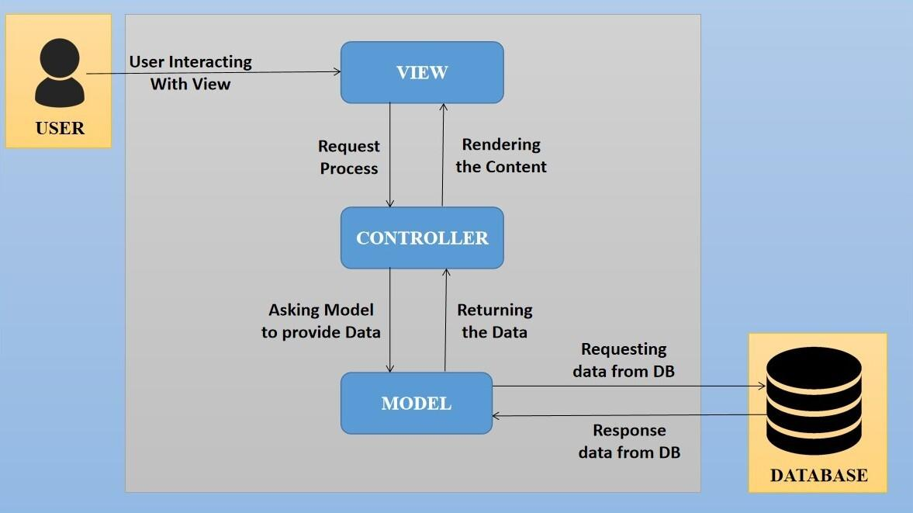

The proposed design is an architectural pattern that separates an application into three main logical

components: The **Model**, the **View** and the **Controller**. Each of these components are built to handle

specific development aspects of the application like:

* The Model component corresponds to all the data-related logic that the user works with. This can represent either the data that is being transferred between the View and Controller components or any other business logic-related data
* The View component is used for all the UI logic of the application. It generates a user interface for the user
* The controller is the component that enables the interconnection between the views and the model so it acts as an intermediary

## Interoperability Framework

Frappe is a full stack, batteries-included, web framework written in Python and JavaScript with MariaDB as the database. It is pretty generic and can be used to build database-driven apps with an elegant and consistent UI.

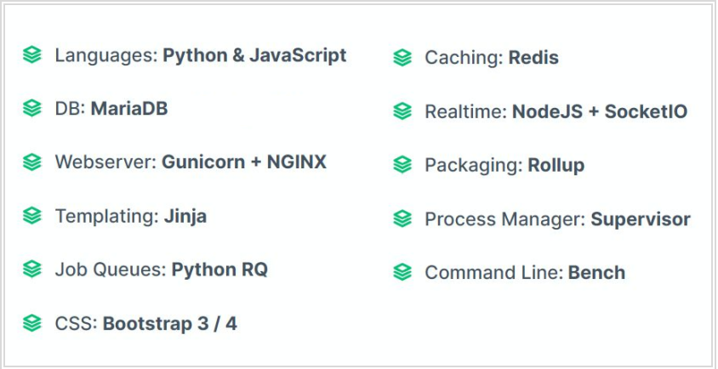

## Technical Decision Summary

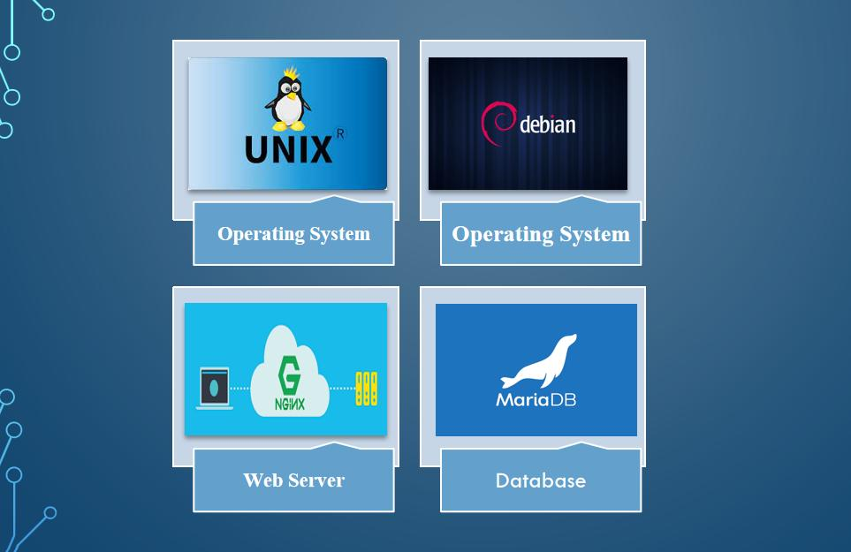

## Architectural Risks & Mitigation

|  |  |
| --- | --- |
| **Risks** | **Recommendation** |
| Inability to provide the required hardware resources (Server) for installation of the ERP product | The issue should be brought up during cadence meetings, and the OCAC/WSC IT team should assure timely availability of the required server |
| Unavailability of API for third party integration | The project timeline schedule needs to be shared with third parties to avoid the delay in integration. Also, inclusion of external teams to meet timelines |

## Reference

|  |  |
| --- | --- |
| ***Sl No.*** | ***Document Name*** |
| 1 | SRS for Infrastructure Project Plan and Monitoring |
|  |  |

# Enterprise Architecture Framework (Business Architecture)

## Business Drivers

The following points motivate the business efficacy of Campus Management Software at World Skill Center (WSC) system:

* Integrate the various functions such as Admission, Academics, Examination, Training & Placement, HRMS, Procurement, Finance into a single platform which can be customized as per user requirements
* Implement a common framework for the system and sub systems
* Provide web based application for the users to interact with the system with Role based Access and consistent look and feel

## Business Concerns

Campus Management Software At World Skill Center application is designed to address the following concerns:

Student Management: To help the students / trainers manage the students admission activities, starting from initial communication to course enrollment

Financial Management: Managing finances is a fundamental concern for businesses. This includes budgeting, cash flow management, ledger maintenance, balance sheet,etc

Employee Engagement: Attracting, retaining, and engaging skilled and motivated employees is critical. Human resources concerns also include training, performance management

Procurement management: The source-to-settle process. It encompasses the evaluation, selection, and creation of formal contractual agreements as well as managing the company's ongoing supplier relationships

## Business Goals

The goal is to implement a web based Campus Management Application System for efficient internal functioning of World Skill Center (WSC) with on-line delivery of services to each stakeholder of WSC supported by a suitable, robust, secure and reliable system

## Business Value Chain

The ERP system's business value chain typically encompasses the following key components:

Procurement Management: This includes the processes related to sourcing and acquiring raw materials, goods, or services required for the organization's operations. The ERP system streamlines procurement activities, such as supplier management, purchase requisitions, purchase orders, and inventory management, leading to cost savings and better supply chain management.

Production/Operations Management: The ERP system facilitates the planning, scheduling, and execution of production processes. It optimizes resource allocation, tracks work progress, manages bills of materials, and monitors production costs to enhance overall operational efficiency and quality.

Inventory Management: The ERP system enables real-time tracking of inventory levels, stock movements, and stock outs. It helps in maintaining optimal inventory levels, reducing carrying costs, and ensuring timely availability of products.

Financial Management: ERP systems centralize financial data and automate accounting, financial reporting, budgeting, and financial analysis. This streamlines financial processes, enhances accuracy, and provides management with a clear financial overview for better decision-making.

Human Resources Management: ERP systems handle various HR functions, including payroll, employee records, recruitment, performance management, and training. This leads to streamlined HR processes, improved workforce management, and enhanced employee satisfaction.

## Business Context Diagram

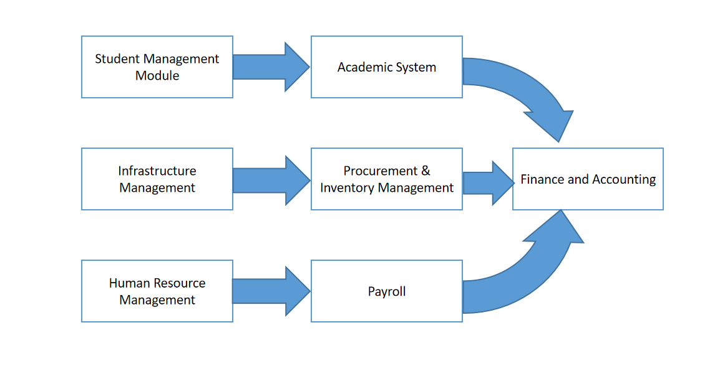

## Business Process Flow

### Procurement and Inventory management

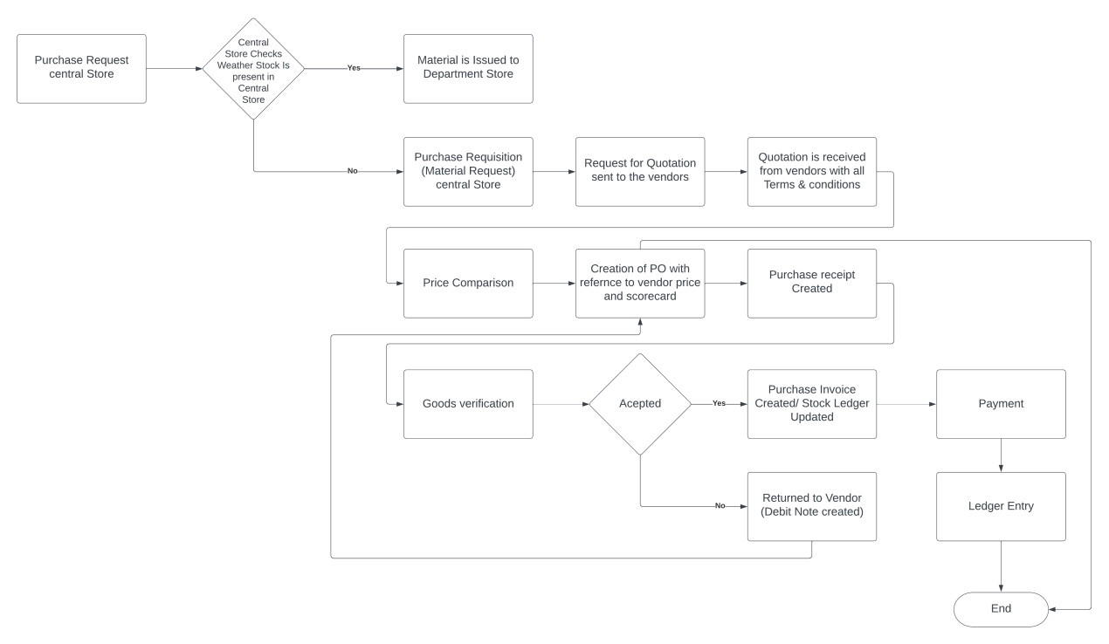

### Asset Management

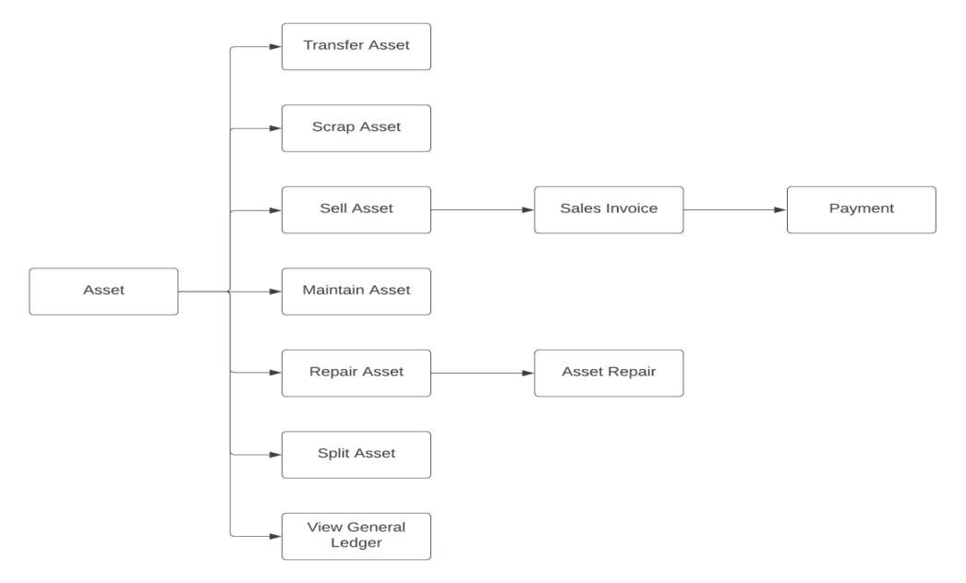

### Asset Repair

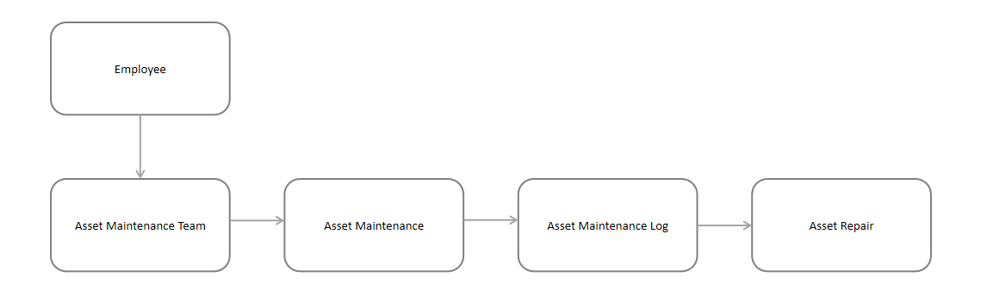

### System Context Diagram

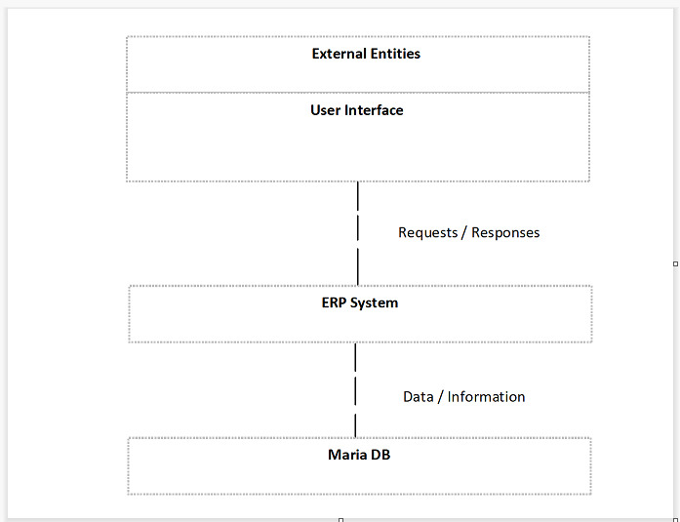

## Conceptual Architecture

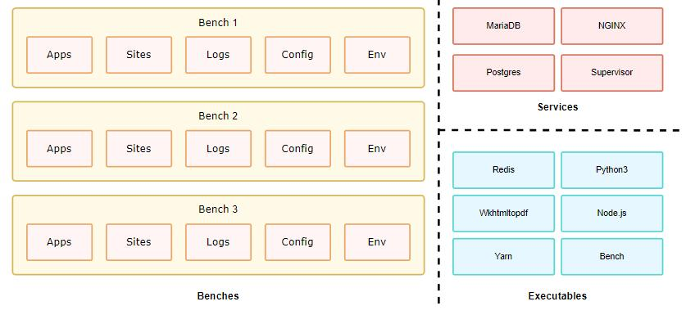

A single bench can host multiple combinations of sites and apps. For the most part, having a single bench works for hosting hundreds of sites that depend on the same versions of said app, given you've scaled up the workers. You can host multiple versions of the application on the same server by creating multiple benches parallelly. The following diagram hints to the system dependencies and how they are used.

# Architecture Views

## Item

Item can be a product or a service **offered by your company.** The term Item is also applicable to raw materials or components of products yet to be produced.

### Use Case Diagram

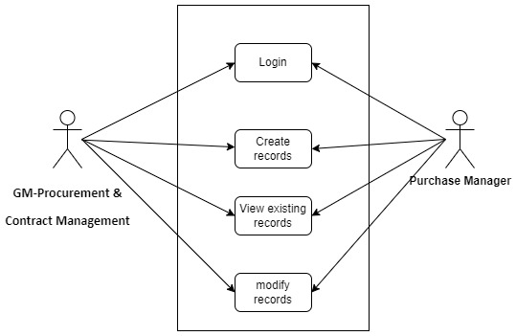

Figure : Item Use case diagram

### 

### Design of Workflow

* Design workflow is not applicable to this screen as records in this are created by only one role and are not sent to users with other roles for approval or modification

### Validations

The data entered on this page will undergo a 2 step validation (I.e. client side and server side validation).

The following validation is done on client side:

1. Mandatory checks for fields : Item code, Item group, UOM, Supplier
2. Auto generate Item Code

The following Processes button will appear after the form is saved:

1. View:
   1. Stock Balance
   2. Stock Ledger
   3. Stock Projected Quantity
2. Action
   1. Publish on website
   2. Add/ Edit Pieces
3. Duplicate

**Client Side Validation**

Client-side validation refers to the process of validating user input directly on the client's web browser before saving it to the server for further processing. Following are some client side validations done for Item screen.

* **Fetching of Employee Details :**

1. Declare a function that is triggered when the "item_group" field in the "Item" form is changed. The function takes an argument "frm"
2. Declare a variable named "group" and initialize it as an empty string
3. Extract the first four characters from the "item_group" field of the current form document (cur_frm.doc.item_group) and convert them to uppercase. Assign the result to the "group" variable
4. Set the value of the "item_code" field in the form to the value of the "group" variable.
5. Refresh the "item_code" field to update its display
6. End of the function

**Notification**

1. Notification to be sent to Procurement department before 30 days of a product expiry date/ Warranty period to expire
2. Retrieve a list of items along with their item codes, item names, creation dates, and warranty periods from the "Item" table
3. For each item in the item list, do the following:
   1. Get the creation date of the item
   2. Convert the creation date from date and time format to date format
   3. If the item's warranty period is not None:
      1. Convert the warranty period to an integer
      2. Calculate the warranty end date by adding the warranty period in days to the creation date
      3. Get the current date
      4. Calculate the difference between the warranty end date and the current date
      5. Convert the date difference to an integer representing the number of days
      6. If the date difference is equal to 30 or the date difference is less than or equal to 30 and greater than 0:
4. Call the function "item_expiry" with the item details as parameters which contains recipients, Subject of email, body of message as parameter for sending email
5. Notification to be sent to Procurement department if any Item has reached the defined the Safety stock level
6. Retrieve a list of items and their safety stock from the "Item" table
7. For each item in the item list, do the following:
   1. Get the item code
   2. Retrieve the sum of the actual quantities from the "Stock Ledger Entry" table for the current item
   3. Store the remaining stock value in a variable
   4. If the remaining stock value is not None:
      1. Check if the remaining stock is less than or equal to the safety stock for the item
      2. If the condition is true, call the function "safety_stock_reach_notification" with the item details as parameters which contains recipients, Subject of email, body of message as parameter for sending email

### Field List:

|  |  |  |  |  |  |  |
| --- | --- | --- | --- | --- | --- | --- |
| **ID** | **Label** | **Type** | **Validation/Action** | **Mandatory** | **Remarks** | **R= Rename**  **N= New**  **D= Delete** |
|  | **Details(Tab Break)** | | | | | |
| 1 | Item Code | Text Field | User will give input  (Validation logic will change) | Yes | Item code will generate automatically  according to the Item Group (ex : If item group name is Stationary then name should be STAT-0001) |  |
| 2 | Item Name | Text Field | User will give input |  |  |  |
| 3 | Item Group | Link | Value will be fetched from Item Group list,User will select any one. | Yes |  |  |
| 4 | HSN/SAC | Link | User will give input |  | Harmonized System of Nomenclature (HSN) and Service Accounting Code (SAC) for GST. These numbers are defined by the government and different Items fall under different codes. New HSN codes can be added if not present in the list. |  |
| 5 | Is Non GST | Checkbox | User will checked the checkbox for an item that is not covered under GST. Eg: petrol. |  |  |  |
| 6 | Default Unit of Measure | Link | Link with UOM | Yes | This is the default measuring unit that you will use for your product. It could be Nos, Kgs, Meters, etc. |  |
| 7 | Disabled | Checkbox | If you disable an Item, it cannot be selected in any transaction. |  |  |  |
| 8 | Maintain Stock | Checkbox | If you are maintaining stock of this Item in your Inventory,then it will make a stock ledger entry for each transaction of this item when checkbox is checked.  Ensure to keep this option unchecked when creating a non-stock Item or a service. |  |  |  |
| 9 | Opening Stock | Number | **Opening Stock is the amount and value of materials that a company has available for sale or use at the beginning of an accounting period.** |  |  |  |
| 10 | Valuation Rate | Currency | Valuation Rate of an item is calculated based on the total expense incurred to make the product available for sale like freight, labour, cost of raw materials, etc. |  |  |  |
| 11 | Standard Selling Rate | Currency | When creating an Item, entering a value for this field will automatically create an [Item Price](https://docs.erpnext.com/docs/v13/user/manual/en/stock/item-price) at the back-end. Entering a value after the Item has been saved will not work. In this case, the Item Price is created from any transactions with the Item. The rate at which you'll sell the item. This will be fetched in Sales Orders and Sales Invoices. |  |  |  |
| 12 | Is Fixed Asset | Checkbox | Tick this checkbox if this item is a company Asset. |  |  |  |
| 13 | Auto Create Assets on Purchase | Checkbox | If Item is a Company Asset, tick this checkbox if you want to auto create assets while purchasing this item through [Purchase Cycle](https://docs.erpnext.com/docs/v13/user/manual/en/buying/purchase-order). |  |  |  |
| 14 | Create Grouped Asset | Checkbox | Tick this checkbox if user want to create in a group |  |  |  |
| 15 | Asset Category | Link | Link with asset category this field fetch when “Is Fixed Asset” is checked. |  |  |  |
| 16 | Asset Naming Series | Dropdown | Only one option given for naming Series (ACC-ASS-.YYYY.-). When asset will auto create on that time it help. This field fetch when “Auto Create Assets on Purchase” is checked. |  |  |  |
| 17 | Over Delivery/Receipt Allowance (%) | Number | User will give Input |  |  |  |
| 18 | Over Billing Allowance (%) | Number | User will give Input |  |  |  |
| 19 | Description | Text Editor | Here user can able to mention brief detail about Item |  |  |  |
| 20 | Brand | Link | Link with Brand, If you have more than one brand save them under Brand and pre-select them while filling a New Item. |  |  |  |
|  | **Inventory(Tab Break)** | | | | | |
| 21 | Shelf Life In Days | Number | This is for a product [Batch](https://docs.erpnext.com/docs/v13/user/manual/en/stock/batch). The number of days after which product batch will be unusable. |  |  |  |
| 22 | End of Life | Date Picker | For a single item/product, the date after which it'll be completely unusable. That is, the item will be unusable in transactions and manufacturing |  |  |  |
| 23 | Default Material Request Type | Dropdown | When you create a new Material Request for this item, the field set here will be selected by default in the new Material Request. This is also known as an 'indent'. |  |  |  |
| 24 | Valuation Method | Dropdown | Select the Valuation Method whether FIFO, LIFO or Moving Average. |  |  |  |
| 25 | Warranty Period (in days) | Text Field | A warranty period is a time period in which a purchased product may be returned or exchanged. |  |  |  |
| 26 | Weight Per Unit | Number | The actual weight per unit of the item. |  |  |  |
| 27 | Weight UOM | Link | Link with UOM, The Unit of Measure for the item. This can be Nos, Kilo, etc. The Weight UoM which you use internally can be different from the purchase UoM. |  |  |  |
| 28 | Allow Negative Stock | Checkbox | When checked the item will be allowed to go negative even if negative stock is disabled from Stock Settings. This is useful if you don't want to enable negative stock on high value items but few select low value items are allowed to go negative for few days. |  |  |  |
| **29** | **Barcodes** | **Table** | Barcodes can be recorded in Items to quickly scan and add them in transactions. In the Barcodes table you can add an Item's [barcode for scanning](https://docs.erpnext.com/docs/v13/user/manual/en/stock/articles/track-items-using-barcode). |  | This table is describe below |  |
| **30** | **Reorder level based on Warehouse** | **Table** | When the stock of an item dips under a certain quantity, you can set an automatic reorder under 'Auto Reorder' section. This should be enabled in [Stock Settings](https://docs.erpnext.com/docs/v13/user/manual/en/stock/stock-settings" \l "9-automatic-material-request). This will raise a [Material Request](https://docs.erpnext.com/docs/v13/user/manual/en/stock/material-request) for the Item. The user with roles Purchase Manager and Stock Manager will be  **notified** when the Material Request is created. |  | This table is describe below |  |
| **31** | **UOMs** | **Table** | You can add alternate UoMs for an Item. If the default UoM in which you sell is numbers (NoS) but you receive it in Kilos, you can set an additional UoM with an appropriate conversion factor |  | This table is describe below |  |
| 32 | Has Batch No | Checkbox | Options for batch number, expiry date, and retaining sample stock will be revealed on ticking this checkbox. You cannot activate this if there is any pre-existing transaction for this item. If this is disabled, you'll have to enter the serial numbers manually for every transaction. |  |  |  |
| 33 | Automatically Create New Batch | Checkbox | If the batch number is not mentioned in transactions, then they will be automatically created according to a format like AAAA.00001. If you always want to manually create a batch number for this item, leave this field blank. This setting will override 'Naming Series Prefix' in Stock Settings. Batch numbers can be set to be generated automatically if you manufacture the Items or can be entered manually if it comes from an external manufacturer. |  |  |  |
| 34 | Batch Number Series | Text Field | Prefix that'll be applied to batch numbers. If you set 5x1SCR, then the first batch will be named like 5x1SCR00001 on first transaction/manufacture. |  |  |  |
| 35 | Has Expiry Date | Checkbox | If you tick this, the batch number will be created according to the expiry date. The expiry dates can be set in the 'Batch' master. |  |  |  |
| 36 | Max Sample Quantity | Number | User will give Input |  |  |  |
| 37 | Has Serial No | Checkbox | This is similar to Batch Number Series, it'll be created when you make transactions/manufacture. |  |  |  |
| 38 | Serial Number Series | Text Field | If you set Serial Number Series as AA, then on the first transaction a serial number like AA00001 will be created. |  |  |  |
|  | **Accounting(Tab Break)** | | | | | |
| **39** | **Item Defaults** | **Table** | In this Table, you can define Company-wide transaction-related defaults for this Item. |  | This table is describe below |  |
|  | **Purchasing(Tab Break)** | | | | | |
| 40 | Default Purchase Unit of Measure | Link | Link with UOM, that will be used in Purchase transactions. |  |  |  |
| 41 | Minimum Order Qty | Number | The minimum quantity required for purchase transactions like Purchase Orders. If set, the system will not let you proceed with the purchase transaction if the item quantity in the purchase transaction is lesser than the quantity set in this field. |  |  |  |
| 42 | Safety Stock | Number | “Safety Stock” is used in the report “Itemwise Recommended Reorder Level”. Based on Safety Stock, average daily consumption and the lead time, the system suggests Reorder Level of an item. |  |  |  |
| 43 | Allow Purchase | Checkbox | User will tick then it allow you to purchase |  |  |  |
| 44 | Last Purchase Rate | Number | The rate at which you last purchased this item using a [Purchase Invoice](https://docs.erpnext.com/docs/v13/user/manual/en/accounts/purchase-invoice) will be displayed here. Before Purchase Invoice field will be not visible. |  |  |  |
| 45 | Is Customer Provided Item | Checkbox | Checked if Item is provided by a customer and received through **Material Receipt**. If Checked, **Customer** field is Mandatory as the default customer for **Material Request**. |  |  |  |
| 46 | Customer | Link | Link with Customer |  |  |  |
| 47 | Delivered by Supplier (Drop Ship) | Checkbox | If the item is delivered directly by the supplier to the customer, tick this checkbox. |  |  |  |
| **48** | **Supplier Items** | **Table** | Track Item Code defined by the Suppliers for this Item. In the Purchase transactions, on selecting an Item, a Supplier Part No. will be fetched as well for the Supplier's reference. |  | This table is describe below |  |
| 49 | Enable Deferred Expense | Checkbox | You can enable deferred expense from the item. Once you tick the checkbox, you'll see options to set the Deferred Expense Account and the number of months through which the revenue/expense is deferred. |  |  |  |
| 50 | Deferred Expense Account | Link | Link with Account |  |  |  |
| 51 | No of Months (Expense) | Number | User will give Input |  |  |  |
| 52 | Country of Origin | Link | Link with Country, The country from which you're sourcing the item. |  |  |  |
| 53 | Customs Tariff Number | Link | You can create a customs tariff number with a description and use it for reference here to share with custom agencies. |  |  |  |
|  | **Tax(Tab Break)** | | | | | |
| **54** | **Taxes** | **Table** | Here user will mention default Tax |  | This table is describe below |  |
|  | **Quality(Tab Break)** | | | | | |
| 55 | Inspection Required before Purchase | Checkbox | If an inspection is mandatory before the item is purchased, i.e., before you generate Purchase Receipt, tick this checkbox. |  |  |  |
| 56 | Quality Inspection Template | Link | If a Quality Inspection is prepared for this Item, then this template of criteria will automatically be updated in the Quality Inspection table of the Quality Inspection |  |  |  |
| 57 | Inspection Required before Delivery | Checkbox | If an inspection is required at the time of delivery from your Supplier is mandatory for this Item, tick this checkbox. |  |  |  |
| 58 | View | Button | Stock Ledger: On click of this button you will be able to see the stock ledger |  |  |  |
| Stock Balance: On click of this button you will be able to see the stock balance |  |  |  |
| Stock Projected Qty: On click of this button you will see the projected stock o the items based on your previous transaction history |  |  | D |
| 59 | Actions | Button | Publish on Website |  | Not needed as item will not be published on website | D |
| Add/ Edit Prices: On click of this button you will be able to add/ edit item price by creating a new or editing an existing Item price |  |  |  |
| Duplicate | Button | On click of this button you can create a duplicate item with the same details as existing |  |  |  |
|  | **Barcodes (Child Table)** | | | | | |
|  | **Field Label** | **Field Type** | **Validation/Action** | **Mandatory** | **Remarks** | **R/N/D** |
| 1 | Barcode | Text Field | User will give input according to Barcode Type. If User select EAN then it will give 13 digit number and If user select UPS-A then it will give 12 digit number. | Yes |  |  |
| 2 | Barcode Type | Dropdown | Two option are given but user will select any one :-   * EAN * UPS-A |  |  |  |
| 3 | UOM | Link | Value will fetched from UOM and user will select any one, the standardized measurement unit used to count stock items and to express them as specific quantities. |  |  |  |
|  | **Reorder level based on Warehouse (Child Table)** | | | | | |
|  | **Field Label** | **Field Type** | **Validation/Action** | **Mandatory** | **Remarks** | **R/N/D** |
| 1 | Check in (group) | Link | Value will fetched from Warehouse and user will select any one, In which group warehouses to check the quantity of the item. |  |  |  |
| 2 | Request for | Link | Value will fetched from Warehouse and user will select any one, In Which warehouse to stock the item reorder. | Yes |  |  |
| 3 | Re-order Level | Number | User will give Input and When this quantity is reached, the reorder will be triggered. Re-order level can be determined based on the lead time and the average daily consumption. | Yes |  |  |
| 4 | Re-order Qty | Number | User will give input. The number of units to be reordered so that the sum of ordering cost and holding cost is at its minimum. The re-order quantity is based on the 'Minimum Order Qty' specified by the supplier and many other factors |  |  |  |
| 5 | Material Request Type | Dropdown | * Purchase * Transfer * Material Issue * Manufacture   (User will select any one of them) | Yes |  |  |
|  | **UOM Conversion Detail (Child Table)** | | | | | |
|  | **Field Label** | **Field Type** | **Validation/Action** | **Mandatory** | **Remarks** | **R/N/D** |
| 1 | UOM | Link | Value will fetched from UOM and user will select any one |  |  |  |
| 2 | Conversion Factor | Number | User will give input |  |  |  |
|  | **Item Defaults (Child Table)** | | | | | |
|  | **Field Label** | **Field Type** | **Validation/Action** | **Mandatory** | **Remarks** | **R/N/D** |
| 1 | Company | Link | Value will fetched from Company. Default data will fetched but user can able to change. | Yes |  |  |
| 2 | Default Warehouse | Link | Value will fetched from Warehouse. Default data will fetched but user can able to change. |  |  |  |
| 3 | Default Price List | Link | Value will fetched from Price List and user will select any one |  |  |  |
| 4 | Default Discount Account | Link | Value will fetched from Account and user will select any one |  |  |  |
| 5 | Default Buying Cost Center | Link | Value will fetched from Cost Center and user will select any one |  |  |  |
| 6 | Default Supplier | Link | Value will fetched from Supplier and user will select any one |  |  |  |
| 7 | Default Expense Account | Link | Value will fetched from Account and user will select any one |  |  |  |
| 8 | Default Provisional Account | Link | Value will fetched from Account and user will select any one |  |  |  |
| 9 | Default Selling Cost Center | Link |  |  | It is for a Selling module | D |
| 10 | Default Income Account | Link |  |  | It is for a Selling module | D |
|  | **Supplier Items (Child Table)** | | | | | |
|  | **Field Label** | **Field Type** | **Validation/Action** | **Mandatory** | **Remarks** | **R/N/D** |
| 1 | Supplier | Link | Value will fetched from Supplier and user will select any one | Yes |  |  |
| 2 | Supplier Part Number | Text Field | User will give input |  |  |  |
|  | **Taxes (Child Table)** | | | | | |
|  | **Field Label** | **Field Type** | **Validation/Action** | **Mandatory** | **Remarks** | **R/N/D** |
| 1 | Item Tax Template | Link | Value will fetched from Item Tax Template and user will select any one | Yes |  |  |
| 2 | Tax Category | Link | Value will fetched from Tax Category and user will select any one |  |  |  |
| 3 | Valid From | Date Picker | User will give date |  |  |  |
| 4 | Minimum Net Rate | Number | User will give input |  |  |  |
| 5 | Maximum Net Rate | Number | User will give input |  |  |  |

### Processes After Form Submission

After data entered in Item form is saved, the following processes take place:

1. **View**:
   1. **Stock Balance**:

Make a custom button that would redirect to the query report Stock Balance when clicked

* 1. **Stock Ledger**:

Make a custom button that would redirect to the query report Stock Ledger when clicked

* 1. **Stock Projected Quantity**:

Make a custom button that would redirect to the query report Stock Ledger when clicked

1. **Action**
   1. **Publish on website**:
      1. Make a call to the server-side method "make_website_item" from the "e_commerce.doctype.website_item.website_item" module
      2. Pass the current document (frm.doc) as an argument to the method
      3. Freeze the screen and display the message "Publishing Item ..." during the execution of the method
      4. After the method completes, execute a callback function with the result
      5. Inside the callback function, display a message indicating that the website item has been created
      6. The message includes a hyperlink to the created item's page, with the item's name as the link text
      7. Set the message title as "Published" and display it with a green indicator
      8. If the condition in the previous block is false:
         1. Add a custom button labeled "Website Item" to the form
         2. When the button is clicked, retrieve the name of the associated website item based on the item code from the "Website Item" table
         3. If no website item is found, throw an error with the message "Website Item not found"
         4. If a website item is found, navigate to the "Website Item" form page with the retrieved item's name
   2. **Add/ Edit Pieces**:

Make a custom button that would redirect to the Item Price screen when clicked

1. **Duplicate**:
   * 1. Add a custom button labeled "Duplicate" to the form (frm)
     2. When the "Duplicate" button is clicked, do the following:
        1. Create a new_item variable by making a copy of the current document (frm.doc) using the frappe.model.copy_doc() function
        2. Check if the item name of the new_item is the same as the item code. If it is, set the item name to null to avoid a "copy paste" error
        3. Check if either the item code or description of the new_item is the same as the description. If either of them is, set the description to null
        4. Set the route to the "Item" form page for the duplicated item (new_item.name)

### Process Flow:

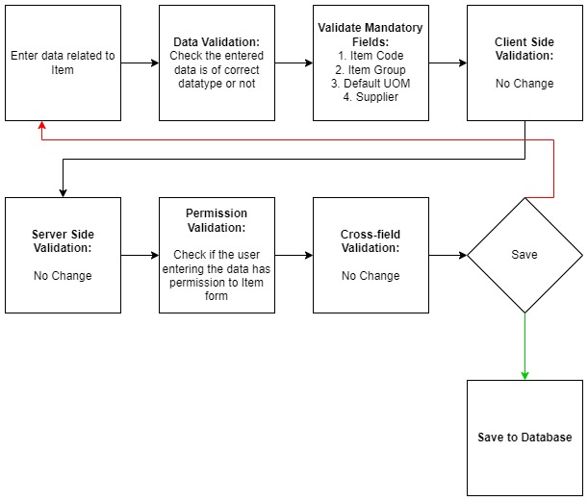

Figure : Item Validation Flow

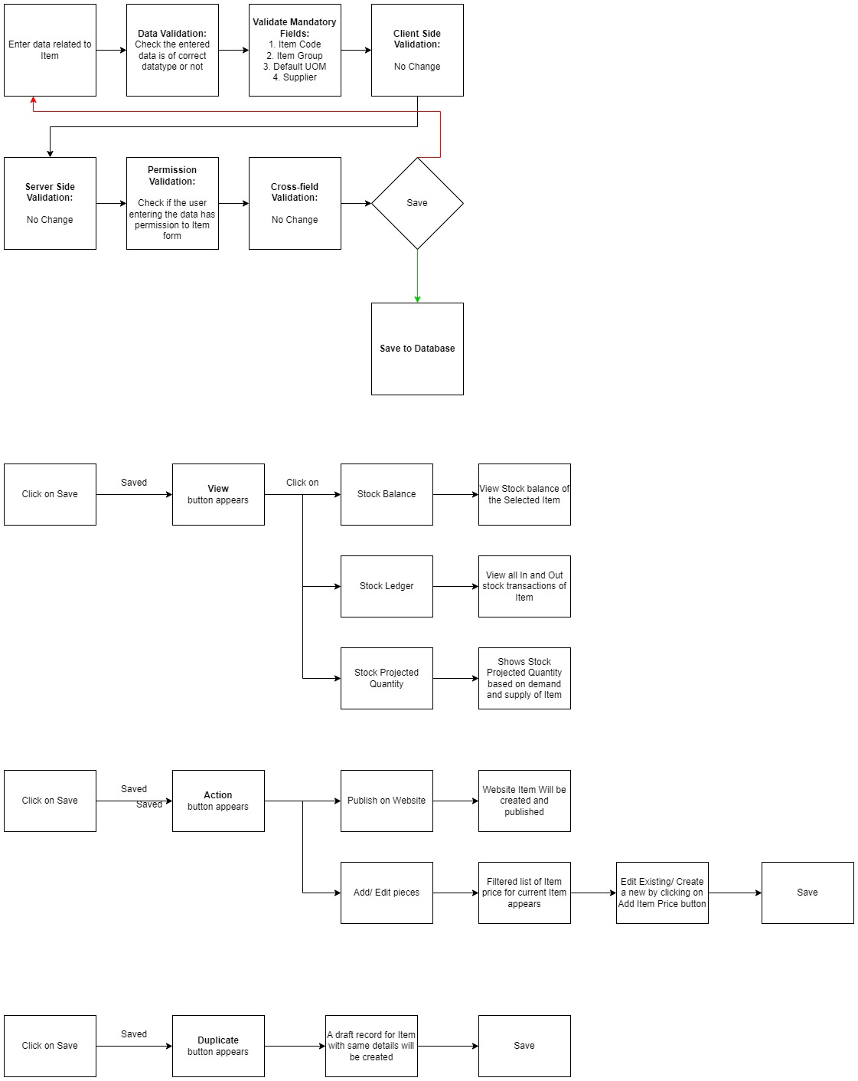

Figure : View Button Flow



Figure : Action button Flow



Figure : Duplicate button Flow

### Pre-requisites and Dependency

* Item Group
* Warehouse
* Unit of Measure

## Item Price

**Item Price is the record in which you can log the selling and buying rate of an item.**

### Use Case Diagram

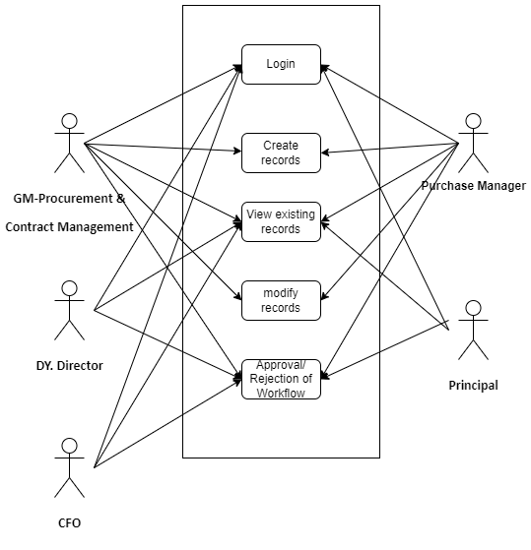

Figure : Item Price Use case diagram

### Design of Workflow

**Design of Workflow**

Create a new workflow named "Item Price Impalement Workflow" for the Item Price Screen.

Configure the workflow with the following stages:

Stage 1:

Purchase Manager creates a new entry for Item Price of Impalement items

Stage 2:

This change in price will be verified and either be approved or rejected by GM- Procurement and Inventory management.

Stage 3:

If Approved by GM- Procurement and Inventory management, the workflow will go to Dy, Director for Approval.

Stage 4:

After Approval from Dy. Director the next stage of workflow will be verification by Principal

Stage 5:

The last stage of this workflow is by CFO who if approves the Change in Impalement price will be submitted and an email to the supplier of the Item will be send.

### Validations

**Client Side Validation:**

The following validation is done on client side:

1. **Mandatory checks for fields :** Item code, Price List and rate

**Server Side Validation:**

* Not Applicable

**Notification:**

* This section is not applicable since there is no notifications to be triggered

### Field List:

|  |  |  |  |  |  |  |  |
| --- | --- | --- | --- | --- | --- | --- | --- |
| **ID** | **Label** | **Type** | | **Validation/Action** | **Mandatory** | **Remarks** | **R= Rename**  **N= New**  **D= Delete** |
| 1 | Item Code | Link | | Value will fetched from Item Code and user will select any one | Yes |  |  |
| 2 | UOM | Link | | Value will fetched from UOM and user will select any one |  |  |  |
| 3 | Packing Unit | Number | | User will give Input |  |  |  |
| 4 | Item Name | Text Field (Read Only) | | After selecting the Item Code , this value will be auto filled. |  |  |  |
| 5 | Brand | Link (Read Only) | | After selecting the Item Code , this value will be auto filled. |  |  |  |
| 6 | Item Description | Text (Read Only) | | After selecting the Item Code , this value will be auto filled. |  |  |  |
| 7 | Price List | Link | | Value will fetched from Price List and user will select any one | Yes |  |  |
| 8 | Customer | Link | | This field will visible when Price List data selected and value will fetched from Customer List and user will select any one |  |  |  |
| 9 | Supplier | Link | | This field will visible when Price List data selected and value will fetched from Supplier List and user will select any one |  |  |  |
| 10 | Batch No | Link | | Value will fetched from Batch and user will select any one |  |  |  |
| 11 | Buying | Checkbox (Read Only) | | After selecting the Price List , this value will be auto tick or un-tick accordingly. |  |  |  |
| 12 | Selling | Checkbox (Read Only) | | After selecting the Price List , this value will be auto tick or un-tick accordingly. |  | It is for a Selling module | D |
| 13 | Currency | Link (Read Only) | | After selecting the Price List, this value will be auto filled. |  |  |  |
| 14 | Rate | Currency | | User will give input | Yes |  |  |
| 15 | Valid From | Date Picker | | User will give date |  |  |  |
| 16 | Lead Time in days | Number | | User will give input |  |  |  |
| 17 | Valid Upto | Date Picker | | User will give date |  |  |  |
| 18 | Note | Text | | User will give input |  |  |  |
| **Action Button** | | | **Description** | | | | |
| Approved | | | On clicking Approved , the status in the form will be updated to Approve. The higher authority will only be able to approve . | | | | |
| Rejected | | | On clicking Rejected, the status in the form will be updated to rejected. The higher authority will only be able to reject. | | | | |

### Processes After Form Submission

* Price Impalement workflow will be active
* Notification for Price change of Impalement Items will be sent to their respective vendor

### Process Flow:

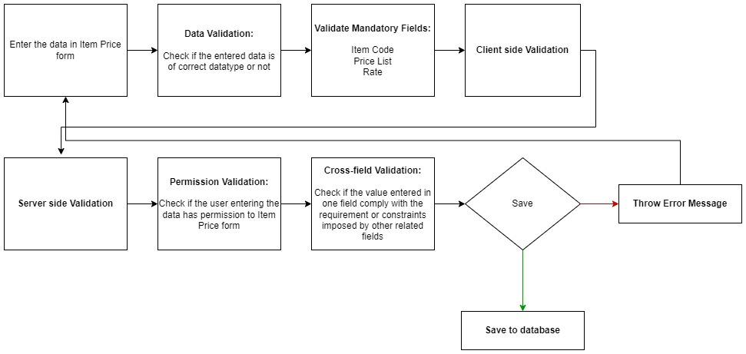

Figure : Item Price Flow

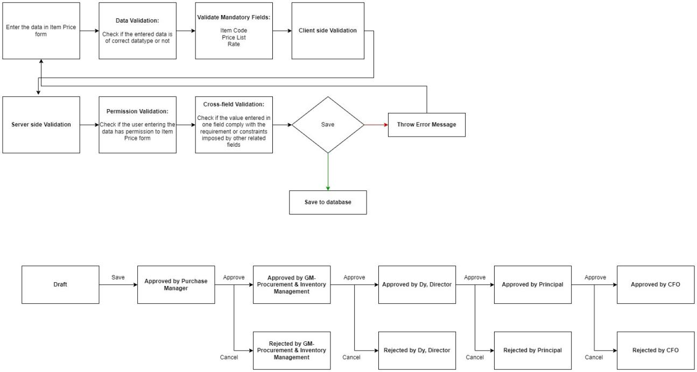

Figure : Item Price Impalement Workflow Flow

### Pre-requisites and Dependency

* Item
* Price List

## Purchase Requisition

**A** Purchase requisition **is a simple document identifying a requirement of a set of Items (products or services) for a particular reason.**

### Use Case Diagram

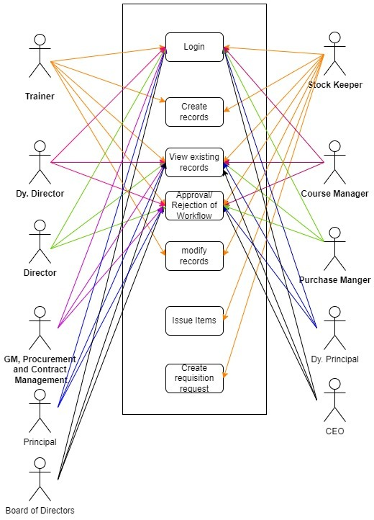

Figure : Purchase requisition Use case diagram

### Design of Workflow

Create a new workflow named "Purchase requisition Workflow" for the Purchase requisition Screen. This workflow will be triggered when purpose is Purchase.

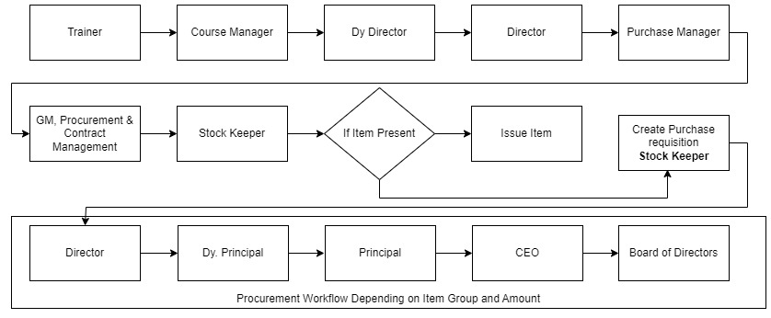

Figure : Purchase requisition Workflow

If the Purpose for material_request_type is Material Transfer or Material Issue the approval steps will be:

1. Trainer
2. Course Manager
3. Dy. Director
4. Director
5. Purchase Manager
6. GM, Procurement and Contract Manager
7. Stock Keeper

Stock Keeper will check for Stock in store and if present will issue to the department else it will create requisition by following criteria:

**Criteria A1:** Get Item Group from Item code, and If Item Group = Furniture/Computers/   
Laptops/Printers/electronic items

* Stock Keeper will create the requisition request and sent to Principal for Approval
* After Principal Approves the requisition it will be sent to Chief Executive Officer for Approval

**Criteria A2:**  Get Item Group from Item code, and If Item Group = training/teaching / learning materials / IEC materials

* Stock Keeper will create the requisition request and sent to Director if the net value of the item requested for is Upto 25000
* Stock Keeper will create the requisition request and sent to Dy Principal if the net value of the item requested for is between 25000 and 50000
* Stock Keeper will create the requisition request and sent to Principal if the net value of the item requested for is between 50000 and 100000
* Stock Keeper will create the requisition request and sent to Chief Executive Officer if the net value of the item requested for is more than 100000

**Criteria A3:**  Get Item Group from Item code, and If Item Group = office stationery & computer stationery

* Stock Keeper will create the requisition request and sent to Director if the net value of the item requested for is Upto 25000
* Stock Keeper will create the requisition request and sent to Dy Principal if the net value of the item requested for is between 25000 and 50000
* Stock Keeper will create the requisition request and sent to Principal if the net value of the item requested for is between 50000 and 100000
* Stock Keeper will create the requisition request and sent to Chief Executive Officer if the net value of the item requested for is more than 100000

**Criteria A4:** Get Item Group from Item code, and If Item Group = services like Security/Gardening/Catering/Hostel/Transport

* Stock Keeper will create the requisition request and sent to Director if the net value of the item requested for is Upto 100000
* Stock Keeper will create the requisition request and sent to Dy Principal if the net value of the item requested for is between 100000 and 300000
* Stock Keeper will create the requisition request and sent to Principal if the net value of the item requested for is beyond 300000

**Criteria B1:**  Get Item Group from Item code, and If Item Group = estimates of construction/repairs and interior designing.

* Stock Keeper will create the requisition request and sent to Board of Directors for approval of any amount

**Criteria C1:**  Get Item Group from Item code, and If Item Group = Consultancy/Auditor/Service Providers/Security/ and all other agency.

* Stock Keeper will create the requisition request and sent to Principal for approval of amount upto 10 Lakh
* Stock Keeper will create the requisition request and sent to Chief Executive Officer for approval of amount from 10 Lakh to 1 crore
* Stock Keeper will create the requisition request and sent to Board of Directors for approval of any amount above 1 crore

**Criteria F1:**  Get Item Group from Item code, and If Item Group = Telephone/ Internet/ Electricity& Water bill payment

* Stock Keeper will create the requisition request and sent to Dy. Principal for approval

**Criteria F2:**  Get Item Group from Item code, and If Item Group = AMC of Lifts/ HVAC/ Computers/ Copiers/ Fax/ AC/ Furniture etc.

* Stock Keeper will create the requisition request and sent to Director for approval of amount upto 20000
* Stock Keeper will create the requisition request and sent to Dy. Principal for approval of amount from 20000 to 50000
* Stock Keeper will create the requisition request and sent to Principal for approval of amount from 50000 upto 5 Lakh
* Stock Keeper will create the requisition request and sent to Chief Executive Officer for approval of amount from 5 lakh to 50 Lakh
* Stock Keeper will create the requisition request and sent to Board of Directors for approval of any amount above 50 lakh

**Criteria F3:**  Get Item Group from Item code, and If Item Group = Sanction of expenditure on training/ workshop/ exposure/ mobilization/ campaign/ events etc.

* Stock Keeper will create the requisition request and sent to Director for approval of amount upto 50000
* Stock Keeper will create the requisition request and sent to Dy. Principal for approval of amount from 50000 to 1 Lakh
* Stock Keeper will create the requisition request and sent to Principal for approval of amount from 1 Lakh upto 5 Lakh
* Stock Keeper will create the requisition request and sent to Chief Executive Officer for approval of amount over 5 lakh

**Criteria F4:**  Get Item Group from Item code, and If Item Group = Sanction of Payment towards hiring of monthly vehicles (All vehicles)

* Stock Keeper will create the requisition request and sent to Director for approval of amount upto 50000
* Stock Keeper will create the requisition request and sent to Dy. Principal for approval of amount upto 1 Lakh
* After approval from Dy. Principal the form is sent to Principal for approval
* After approval from Principal the form is sent to Chief Executive Officer for approval

**Criteria F5:**  Get Item Group from Item code, and If Item Group = Payment towards Advertisement/ Publication Expenses

* Stock Keeper will create the requisition request and sent to Director for approval of amount upto 50000
* Stock Keeper will create the requisition request and sent to Dy. Principal for approval of amount upto 1 Lakh
* After approval from Dy. Principal the form is sent to Principal for approval
* After approval from Principal the form is sent to Chief Executive Officer for approval

**Criteria F6:**  Get Item Group from Item code, and If Item Group = AMC of Lifts/ HVAC/ Computers/ Copiers/ Fax/ AC/ Furniture etc.

* Stock Keeper will create the requisition request and sent to Director for approval of amount upto 20000
* Stock Keeper will create the requisition request and sent to Dy. Principal for approval of amount from 20000 to 50000
* After approval from Dy. Principal the form is sent to Principal for approval
* After approval from Principal the form is sent to Chief Executive Officer for approval

**Criteria F8:**  Get Item Group from Item code, and If Item Group = Any other expenditure not categorized above

* Stock Keeper will create the requisition request and sent to Principal for approval
* After approval from Principal the form is sent to Chief Executive Officer for approval

### Validations

**Client Side Validation:**

Client-side validation refers to the process of validating user input directly on the client's web browser before saving it to the server for further processing.

The following validations are done on client side for Floor Screen:

* Mandatory checks for fields : Purchase, Transaction date, Item code, required by, UOM

**Server Side Validation:**

Server-side validation refers to the process of validating user input on the server to ensure data integrity, security, and adherence to business rules before accepting or processing the information.

Not Applicable.

**Notification:**

* Email should be sent based on workflow for requisition to necessary authority for approval of department-wise requisition
* Once approved by the department head, an email to be sent to the Central store every-time a new requisition is raised
* A receiving email from the receiving department will be sent to the central store upon accepting the required item

### Field List:

|  |  |  |  |  |  |  |
| --- | --- | --- | --- | --- | --- | --- |
| **ID** | **Label** | **Type** | **Validation/Action** | **Mandatory** | **Remarks** | **R= Rename**  **N= New**  **D= Delete** |
|  | **Details(Tab Break)** | | | | | |
| 1 | Series | Dropdown | MAT-MR-.YYYY.-( User will not able to change) |  |  |  |
| 2 | Purpose | Dropdown | * Purchase * Material Transfer * Material Issue * Manufacture * Customer Provided   (User can able to select any one) |  |  |  |
| 3 | Customer | Link | When select Customer Provider in Purpose Field then this field will be visible and Value will fetched from Customer and user will select any one. |  |  |  |
| 4 | Company | Link | Value will fetched from Company and user will select any one |  |  |  |
| 5 | Transaction Date | Date Picker | Date fill fetch auto but user can able to change |  |  |  |
| 6 | Required By | Date Picker | User will give date |  |  |  |
| 7 | Scan Barcode | Text Field | User will give input. By Reader or camera user will also give input |  |  |  |
| 8 | Set Source Warehouse | Link | When select Material Transfer in Purpose Field then this field will be visible and Value will fetched from Warehouse and user will select any one. |  |  |  |
| 9 | Set Target Warehouse | Link | Value will fetched from Warehouse and user will select any one |  |  |  |
| **10** | **Items** | **Table** |  | Yes | This table is describe below |  |
|  | **Terms(Tab Break)** | | | | | |
| 11 | Terms | Link | Value will fetched from “Terms and Conditions” and user will select any one |  |  |  |
| 12 | Terms and Conditions Content | Text Editor | User will give Input |  |  |  |
|  | **More Info(Tab Break)** | | | | | |
| 13 | Status | Dropdown(Read Only) | * Draft * Submitted * Stopped * Cancelled * Pending * Partially Ordered   (Data will fetch automatically) |  |  |  |
| 14 | % Ordered | Percent | This field will be visible when Purchase will be completed |  |  |  |
| 15 | Transfer Status | Dropdown | * Not Started * In Transit * Completed   (Data will fetch automatically) |  |  |  |
| 16 | % Received | Percent | This field will be visible when Purchase will be completed |  |  |  |
| 17 | Letter Head | Link | Value will fetched from Letter Head and user will select any one |  |  |  |
| 18 | Print Heading | Link | Value will fetched from Printing Head and user will select any one |  |  |  |
| 19 | Create | Purchase Order | On click of this button you will be able to create purchase order for the Purchase Requisition |  |  |  |
| 20 | Request for Quotation | On click of this button you will be able to create request for quotation for the Purchase Requisition |  |  |  |
| 21 | Supplier Quotation | On click of this button you will be able to create supplier quotation for the Purchase Requisition |  |  |  |
| 22 | Stop |  | On click of this button you will be able to stop and close Purchase Requisition |  |  |  |
|  | **Items (Child Table)** | | | | | |
|  | **Field Label** | **Field Type** | **Validation/Action** | **Mandatory** | **Remarks** | **R/N/D** |
| 1 | Item Code | Link | Value will fetched from Item and user will select any one | Yes |  |  |
| 2 | Item Name | Text Field | Value will fetch when user will give Item Code field input but user can edit |  |  |  |
| 3 | Required By | Date Picker | User will give date | Yes |  |  |
| 4 | Description | Text Editor | Value will fetch when user will give Item Code field input but user can edit | Yes |  |  |
| 5 | HSN/SAC | Text Field | Value will fetch when user will give Item Code field input but user can edit |  |  |  |
| 6 | Is Non GST | Checkbox | If Checked then GST is not applicable |  |  |  |
| 7 | Item Group | Link (Read Only) | Value will fetch when user will give Item Code field input |  |  |  |
| 8 | Brand | Link (Read Only) | Value will fetch when user will give Item Code field input |  |  |  |
| 9 | Quantity | Number | Value will fetch when user will give Item Code field input but user can edit | Yes |  |  |
| 10 | Stock UOM | Link (Read Only) | Value will fetch when user will give Item Code field input | Yes |  |  |
| 11 | Source Warehouse | Link | Value will link from Warehouse, Value will fetch when user will give Item Code field input but user can edit |  |  |  |
| 12 | Target Warehouse | Link | Value will fetch when user will give Item Code field input but user can edit |  |  |  |
| 13 | UOM | Link | Value will fetch when user will give Item Code field input but user can edit | Yes |  |  |
| 14 | UOM Conversion Factor | Number | Value will fetch when user will give Item Code field input but user can edit | Yes |  |  |
| 15 | Stock Qty | Number (Read Only) | Value will fetch when user will give Item Code field input also it will change when edit Quantity field data |  |  |  |
| 16 | Min Order Qty | Number (Read Only) | Value will fetch when user will give Item Code field input |  |  |  |
| 17 | Projected Qty | Number (Read Only) | Value will fetch when user will give Item Code field input |  |  |  |
| 18 | Actual Qty | Number (Read Only) | Value will fetch when user will give Item Code field input |  |  |  |
| 19 | Completed Qty | Number (Read Only) | Value will fetch when user will give Item Code field input |  |  |  |
| 20 | Received Qty | Number (Read Only) | Value will fetch when user will give Item Code field input |  |  |  |
| 21 | Rate | Currency | Value will fetch when user will give Item Code field input but user can edit |  |  |  |
| 22 | Amount | Currency (Read Only) | Value will fetch when user will give Item Code field input also it will change when edit Quantity and Rate field data |  |  |  |

### 

### Processes After Form Submission

* Not Applicable

### Process Flow:

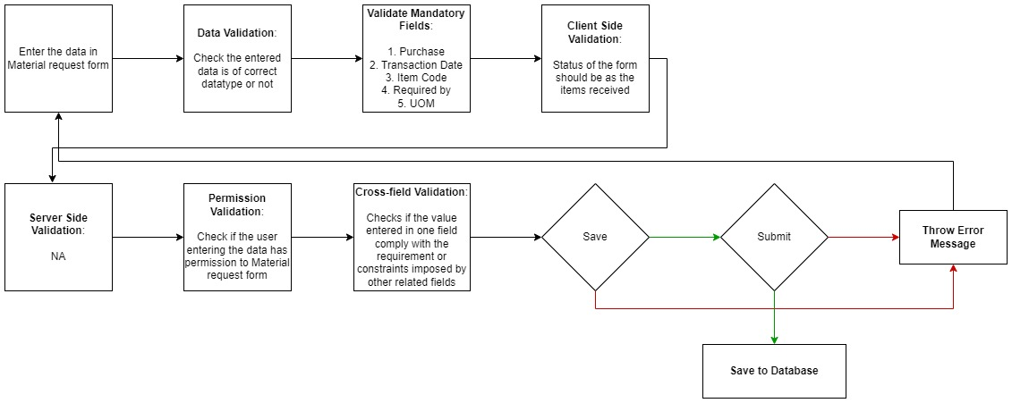

Figure : Purchase Requisition Process Flow

### Pre-requisites and Dependency

* Supplier
* Item
* UOM
* Company

## L1 Vendor Selection report

**L1 Vendor selection report is a report which shows a view of all the supplier quotation received against a quotation released. Thus making the process of Vendor selection process easier.**

### Use Case Diagram



Figure : Vendor selection report Use case diagram

### Design of Workflow

* Not Applicable

### Validations

**Validations**

The data entered on this page will undergo a 2 step validation (I.e. client side and server side validation).

The following validation is done on client side:

1. Fields creation for Filters for Supplier, From Date, To date, Status, Item Code

The following validation is done on server side before save:

1. Get data
2. Get Column

After successful validation check from both client-side and server-side the result in the reports will be shown to user based on the filter that they have set.

**Client Side Validation**

Client-side validation refers to the process of validating user input directly on the client's web browser before saving it to the server for further processing. Following are some client side validations done for vendor selection report.

* **Field creation for Supplier, From Date, To date, Status, Item Code :**

Under filters assign fieldname, label, fieldtype, width, reqd and values for each of the filter values you want

**Server Side Validation**

Server-side validation refers to the process of validating user input on the server to ensure data integrity, security, and adherence to business rules before accepting or processing the information. Following are some server side validations done for vendor selection report.

* **Get_data**

1. Get value passed in filter for From date, To date
2. Write a query to get all supplier quotation between from date and to_date
3. If value for Item code, Supplier and status is provided pass that too while fetching records
4. Return the data fetched through execution of query

* **Get_columns**

1. Pass values for label, fieldname, fieldtype, options and width of the column to be created
2. The columns that will be created for Item code, Item name, quantity, Supplier, rate, taxes and charges, Grand total as:
3. If the length of the head_name list is not equal to 0:

1.1. For each element t in the item_name list:

1.1. Set the label variable as t

1.2. Create a new dictionary called columns_add

1.3. Set the value of the "label" key in columns_add as the string "%s" % (label)

1.4. Set the value of the "fieldname" key in columns_add as the string "%s" % (label)

1.5. Set the value of the "fieldtype" key in columns_add as "Data"

1.6. Set the value of the "width" key in columns_add as 180

1.7. Append columns_add to the columns list

1. Return the columns value to create all columns

**Notification:**

* This section is not applicable since there is no notifications to be triggered

### Field List:

|  |  |  |  |  |  |  |
| --- | --- | --- | --- | --- | --- | --- |
| **ID** | **Label** | **Type** | **Validation/Action** | **Mandatory** | **Remarks** | **R= Rename**  **N= New**  **D= Delete** |
| 1 | Supplier | Text Field |  |  |  | N |
| 2 | Date | Date |  |  |  | N |
| 3 | Valid Till | Date |  |  |  | N |
| 4 | Status | Select | Submitted  Expired |  |  | N |
| 5 | Item Code | Link | Values will be fetched from Item form |  |  | N |
| 6 | Item Name | Text field |  |  |  | N |
| 7 | Item group | Link | Values will be fetched from Item Group form |  |  | N |
| 8 | Quantity | Text |  |  |  | N |
| 9 | UOM | Text |  |  |  | N |
| 10 | Discount | Float |  |  |  | N |
| 11 | Rate | Float |  |  |  | N |
| 12 | Amount | Float |  |  |  | N |
| 13 | Weight | Float |  |  |  | N |
| 14 | Taxes and Charges | Float |  |  |  | N |
| 15 | Grand Total | Float |  |  |  | N |

### Filters:

|  |  |  |  |  |  |  |
| --- | --- | --- | --- | --- | --- | --- |
| **ID** | **Label** | **Type** | **Validation/Action** | **Mandatory** | **Remarks** | **R= Rename**  **N= New**  **D= Delete** |
| 1 | Supplier | Text Field |  |  |  | N |
| 2 | Date | Date |  |  |  | N |
| 3 | Valid Till | Date |  |  |  | N |
| 4 | Status | Select | Submitted  Expired |  |  | N |
| 5 | Item Code | Link | Values will be fetched from Item form |  |  | N |
| 6 | Item Name | Text field |  |  |  | N |
| 7 | Item group | Link | Values will be fetched from Item Group form |  |  | N |
| 8 | Quantity | Text |  |  |  | N |
| 9 | UOM | Text |  |  |  | N |
| 10 | Discount | Float |  |  |  | N |
| 11 | Rate | Float |  |  |  | N |
| 12 | Amount | Float |  |  |  | N |
| 13 | Weight | Float |  |  |  | N |
| 14 | Taxes and Charges | Float |  |  |  | N |
| 15 | Grand Total | Float |  |  |  | N |

### Processes After Form Submission

* Not Applicable

### Process Flow:

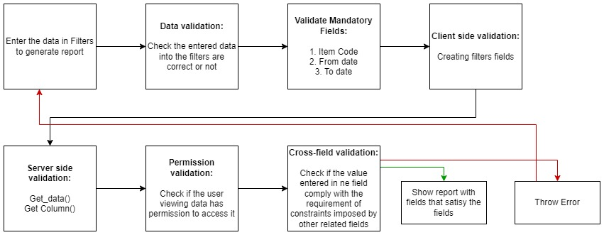

Figure : Vendor selection report Process Flow

### Pre-requisites and Dependency

* Item
* Item group
* Supplier
* UOM
* Purchase Requisition
* Quotation
* Supplier Quotation

## Impaneled Price Change report

**Impaneled price change report is a report which shows change in price of Impaneled prices**

### Use Case Diagram



Figure : Impaneled Price Change report Use case diagram

### Design of Workflow

* Not Applicable

### Validations

The data entered on this page will undergo a 2 step validation (I.e. client side and server side validation).

The following validation is done on client side:

1. Fields creation for Filters for Supplier, From Date, To date, Item Code

The following validation is done on server side before save:

1. Get data
2. Get Column

After successful validation check from both client-side and server-side the result in the reports will be shown to user based on the filter that they have set.

**Client Side Validation**

Client-side validation refers to the process of validating user input directly on the client's web browser before saving it to the server for further processing. Following are some client side validations done for vendor selection report.

* **Field creation for Supplier, From Date, To date, Item Code :**

Under filters assign fieldname, label, fieldtype, width, reqd and values for each of the filter values you want

**Server Side Validation**

Server-side validation refers to the process of validating user input on the server to ensure data integrity, security, and adherence to business rules before accepting or processing the information. Following are some server side validations done for vendor selection report.

* **Get_data**

1. Get value passed in filter for From date, To date
2. Write a query to get all price list between from date and to_date
3. If value for Item code, Supplier is provided pass that too while fetching records
4. Return the data fetched through execution of query

* **Get_columns**

1. Pass values for label, fieldname, fieldtype, options and width of the column to be created
2. Return the columns value to create all columns

**Notification:**

* This section is not applicable since there is no notifications to be triggered

### Field List:

|  |  |  |  |  |  |  |
| --- | --- | --- | --- | --- | --- | --- |
| **ID** | **Label** | **Type** | **Validation/Action** | **Mandatory** | **Remarks** | **R= Rename**  **N= New**  **D= Delete** |
| 1 | Item Code | Link | Values will be fetched from Item form | Y |  | N |
| 2 | Item Name | Text field |  |  |  | N |
| 3 | Price List | Link |  |  |  | N |
| 4 | Rate | Select |  |  |  | N |
| 5 | Currency | Float | Values will be fetched from Currency form |  |  | N |
| 6 | Supplier | Link | Values will be fetched from Supplier form |  |  | N |
| 7 | From Date | Date |  | Y |  | N |
| 8 | To date | Date |  | Y |  | N |

### Filters:

|  |  |  |  |  |  |  |
| --- | --- | --- | --- | --- | --- | --- |
| **ID** | **Label** | **Type** | **Validation/Action** | **Mandatory** | **Remarks** | **R= Rename**  **N= New**  **D= Delete** |
| 1 | Item Code | Link | Values will be fetched from Item form |  |  | N |
| 2 | Item Name | Text field |  |  |  | N |
| 3 | Price List | Link |  |  |  | N |
| 4 | Supplier | Link | Values will be fetched from Supplier form |  |  |  |

### Processes After Form Submission

* Not Applicable

### Process Flow:



Figure : Impaneled Price Change report Process Flow

### Pre-requisites and Dependency

* Item
* Item group
* Item price
* Supplier

## Asset report

**Asset report is a report which shows list and details of all Assets.**

### Use Case Diagram



Figure : Asset report Use Case Diagram

### Design of Workflow

* Not Applicable

### Validations

The data entered on this page will undergo a 2 step validation (I.e. client side and server side validation).

The following validation is done on client side:

1. Fields creation for Filters for Item Code, Item name, Asset owner, Location, Department and status

The following validation is done on server side before save:

1. Get data
2. Get Column

After successful validation check from both client-side and server-side the result in the reports will be shown to user based on the filter that they have set.

**Client Side Validation**

Client-side validation refers to the process of validating user input directly on the client's web browser before saving it to the server for further processing. Following are some client side validations done for vendor selection report.

* **Field creation for Supplier, From Date, To date, Item Code :**

Under filters assign fieldname, label, fieldtype, width, reqd and values for each of the filter values you want

**Server Side Validation**

Server-side validation refers to the process of validating user input on the server to ensure data integrity, security, and adherence to business rules before accepting or processing the information. Following are some server side validations done for vendor selection report.

* **Get_data**

1. Get value passed in filter for From date, To date
2. Write a query to get all necessary fields from Asset table
3. Return the data fetched through execution of query

* **Get_columns**

1. Pass values for label, fieldname, fieldtype, options and width of the column to be created
2. Return the columns value to create all columns

**Notification:**

* This section is not applicable since there is no notifications to be triggered

### Field List:

|  |  |  |  |  |  |  |
| --- | --- | --- | --- | --- | --- | --- |
| **ID** | **Label** | **Type** | **Validation/Action** | **Mandatory** | **Remarks** | **R= Rename**  **N= New**  **D= Delete** |
| 1 | Company | Link | Values will be fetched from Item form |  |  | N |
| 2 | Item Code | Link | Values will fetch values from Item form |  |  | N |
| 3 | Item Name | Text field |  |  |  | N |
| 4 | Asset Owner | Select | Company  Supplier  Customer |  |  | N |
| 5 | Location | Link | Values will be fetched from Location form |  |  | N |
| 6 | Custodian | Link | Values will be fetched from Custodian form |  |  | N |
| 7 | Department | Link | Values will be fetched from Department form |  |  | N |
| 8 | Cost Center | Link | Values will be fetched from Cost center form |  |  | N |
| 9 | Gross Purchase Amount | Date |  |  |  | N |
| 10 | Available-for-use Date | Date |  |  |  | N |
| 11 | Purchase Date | Date |  |  |  | N |
| 12 | Finance Book | Link | Values will be fetched from Finance Book form |  |  | N |
| 13 | Depreciation Method | Select | Straight  Double Declining Balance  Written down value  Manual |  |  | N |
| 14 | Total Number of Depreciation's | Text field |  |  |  | N |
| 15 | Frequency of Depreciation (Months) | Text field |  |  |  | N |
| 16 | Depreciation Posting Date | Date |  |  |  | N |
| 17 | Policy number | Text field |  |  |  | N |
| 18 | Insurer | Text field |  |  |  | N |
| 19 | Insured value | Text field |  |  |  | N |
| 20 | Insurance Start Date | Date |  |  |  | N |
| 21 | Insurance End Date | Date |  |  |  | N |
| 22 | Status | Select | Draft  Submitted  Partially Depreciated  Fully Depreciated  Sold  Scrapped  In Maintenance  Out of Order  Issue  Receipt  Capitalized  Decapitalized |  |  | N |

### Filters:

|  |  |  |  |  |  |  |
| --- | --- | --- | --- | --- | --- | --- |
| **ID** | **Label** | **Type** | **Validation/Action** | **Mandatory** | **Remarks** | **R= Rename**  **N= New**  **D= Delete** |
| 1 | Item Code | Link | Values will fetch values from Item form |  |  | N |
| 2 | Item Name | Text field |  |  |  | N |
| 3 | Asset Owner | Select | Company  Supplier  Customer |  |  | N |
| 4 | Location | Link | Values will be fetched from Location form |  |  | N |
| 5 | Department | Link | Values will be fetched from Department form |  |  | N |
| 6 | Status | Select | Draft  Submitted  Partially Depreciated  Fully Depreciated  Sold  Scrapped  In Maintenance  Out of Order  Issue  Receipt  Capitalized  Decapitalized |  |  | N |

### Processes After Form Submission

* Not Applicable

### 

### Process Flow:

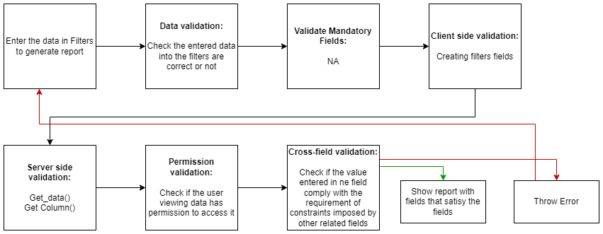

Figure : Asset report Process Flow

### Pre-requisites and Dependency

* Item
* Asset
* Department
* Supplier
* Custodian
* Finance Book

# Tools And Technologies

This section explains the tools that are used to build this design document

* Draw.io - it is an online tool used to develop the flowcharts used in this document.
* WPS office - it is a text editor that has been used to write and assemble this document

# Non-Functional Requirements

## Performance

Specify performance requirements, including response times, transaction throughput, and system scalability

## Reliability

Define the reliability requirements, such as availability, fault tolerance, and disaster recovery

## Usability

Describe usability requirements, including user-friendly interfaces, clear error messages, and intuitive workflows

## Compatibility

Specify compatibility requirements with different operating systems, web browsers, and devices

## Security

Security requirements, including authentication, access control, data encryption, and secure communication protocols

## Compliance

Specify any legal or regulatory compliance requirements, such as GDPR, PCI DSS, or other industry-specific standards

## Documentation

Describe the documentation requirements, including user manuals, developer guides, and API documentation

## Security: User access and authorization

The screens and the data in them is made secure by creating roles with different permissions and then assigning those roles the appropriate users. For this screen following are the roles and their corresponding permissions:

**Item**

|  |  |  |  |  |  |  |  |  |  |
| --- | --- | --- | --- | --- | --- | --- | --- | --- | --- |
| **ID** | **Role** | **Select** | **Read** | **Write** | **Create** | **Delete** | **Submit** | **Cancel** | **Amend** |
| 1 | GM-Procurement & Contract Management | Yes | Yes | Yes | Yes | Yes | NA | NA | NA |
| 2 | Purchase Manager | Yes | Yes | Yes | Yes | Yes | NA | NA | NA |

**Item Price**

|  |  |  |  |  |  |  |  |  |  |
| --- | --- | --- | --- | --- | --- | --- | --- | --- | --- |
| **ID** | **Role** | **Select** | **Read** | **Write** | **Create** | **Delete** | **Submit** | **Cancel** | **Amend** |
|  | GM-Procurement & Contract Management | Yes | Yes | Yes | Yes | Yes | NA | NA | NA |
|  | Purchase Manager | Yes | Yes | Yes | Yes | Yes | NA | NA | NA |
|  | Dy. Director | Yes | Yes | NA | NA | NA | NA | NA | NA |
|  | Principal | Yes | Yes | NA | NA | NA | NA | NA | NA |
|  | CFO | Yes | Yes | NA | NA | NA | NA | NA | NA |

**Purchase Requisition**

|  |  |  |  |  |  |  |  |  |  |
| --- | --- | --- | --- | --- | --- | --- | --- | --- | --- |
| **ID** | **Role** | **Select** | **Read** | **Write** | **Create** | **Delete** | **Submit** | **Cancel** | **Amend** |
|  | GM-Procurement & Contract Management | Yes | Yes | NA | NA | NA | NA | NA | NA |
|  | Purchase Manager | Yes | Yes | NA | NA | NA | NA | NA | NA |
|  | Trainer | Yes | Yes | Yes | Yes | Yes | Yes | Yes | Yes |
|  | Stock Keeper | Yes | Yes | Yes | Yes | Yes | Yes | Yes | Yes |
|  | Course Manager | Yes | Yes | NA | NA | NA | NA | NA | NA |
|  | Dy. Director | Yes | Yes | NA | NA | NA | NA | NA | NA |
|  | Director | Yes | Yes | NA | NA | NA | NA | NA | NA |
|  | Dy, Principal | Yes | Yes | NA | NA | NA | NA | NA | NA |
|  | Principal | Yes | Yes | NA | NA | NA | NA | NA | NA |
|  | CEO | Yes | Yes | NA | NA | NA | NA | NA | NA |
|  | Broad Of Director | Yes | Yes | NA | NA | NA | NA | NA | NA |

**L1 Vendor Selection report**

|  |  |  |  |  |  |  |  |  |  |
| --- | --- | --- | --- | --- | --- | --- | --- | --- | --- |
| **ID** | **Role** | **Select** | **Read** | **Write** | **Create** | **Delete** | **Submit** | **Cancel** | **Amend** |
|  | GM-Procurement & Contract Management | Yes | Yes | NA | NA | NA | NA | NA | NA |
|  | Purchase Manager | Yes | Yes | NA | NA | NA | NA | NA | NA |

**Impaneled price Change report**

|  |  |  |  |  |  |  |  |  |  |
| --- | --- | --- | --- | --- | --- | --- | --- | --- | --- |
| **ID** | **Role** | **Select** | **Read** | **Write** | **Create** | **Delete** | **Submit** | **Cancel** | **Amend** |
|  | GM-Procurement & Contract Management | Yes | Yes | NA | NA | NA | NA | NA | NA |
|  | Purchase Manager | Yes | Yes | NA | NA | NA | NA | NA | NA |

**Asset report**

|  |  |  |  |  |  |  |  |  |  |
| --- | --- | --- | --- | --- | --- | --- | --- | --- | --- |
| **ID** | **Role** | **Select** | **Read** | **Write** | **Create** | **Delete** | **Submit** | **Cancel** | **Amend** |
|  | GM-Procurement & Contract Management | Yes | Yes | NA | NA | NA | NA | NA | NA |
|  | Purchase Manager | Yes | Yes | NA | NA | NA | NA | NA | NA |

**Prototype**

# Prototype

The screen samples that have been derived based on the requirements gathered from the users / SME’s of the **Project Plan Monitoring** module

## Item Group

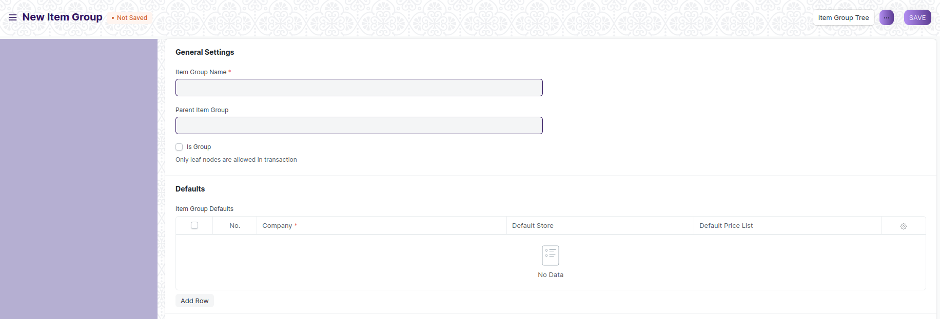

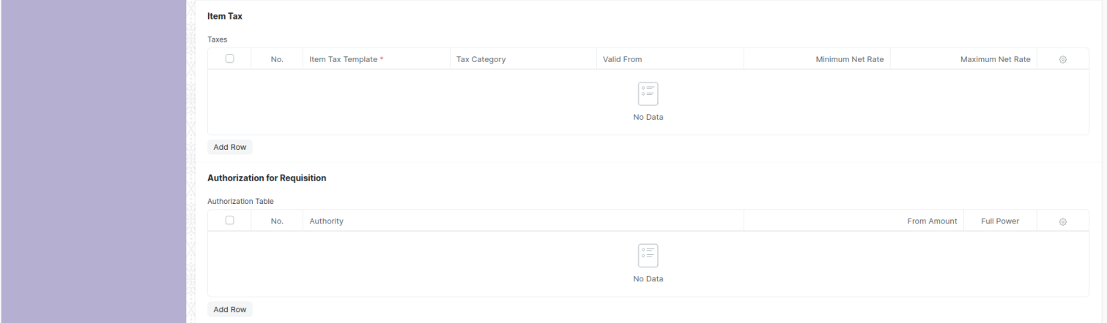

Figure : Item Group

## Item

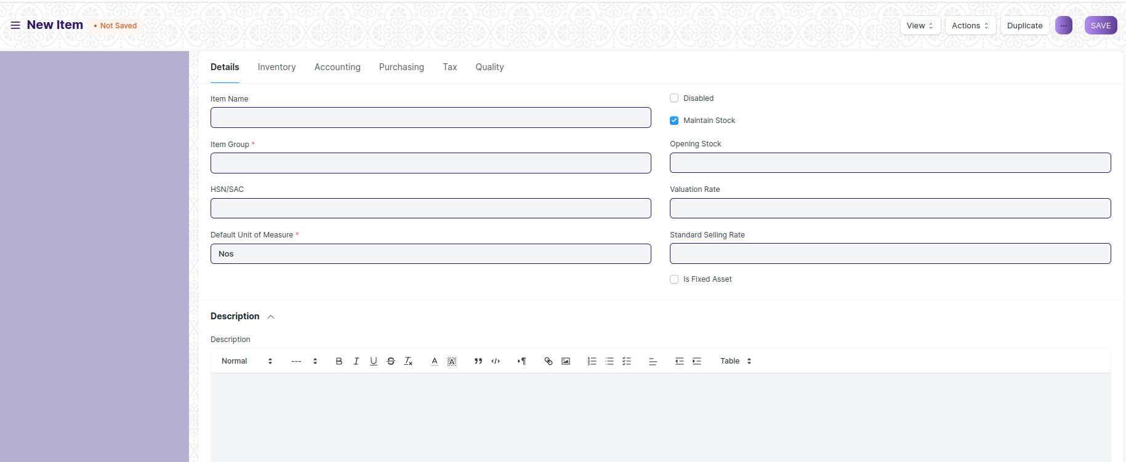

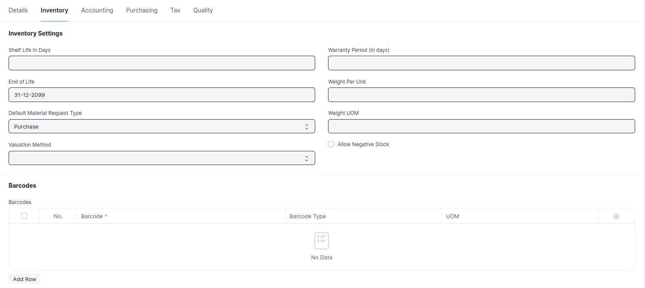

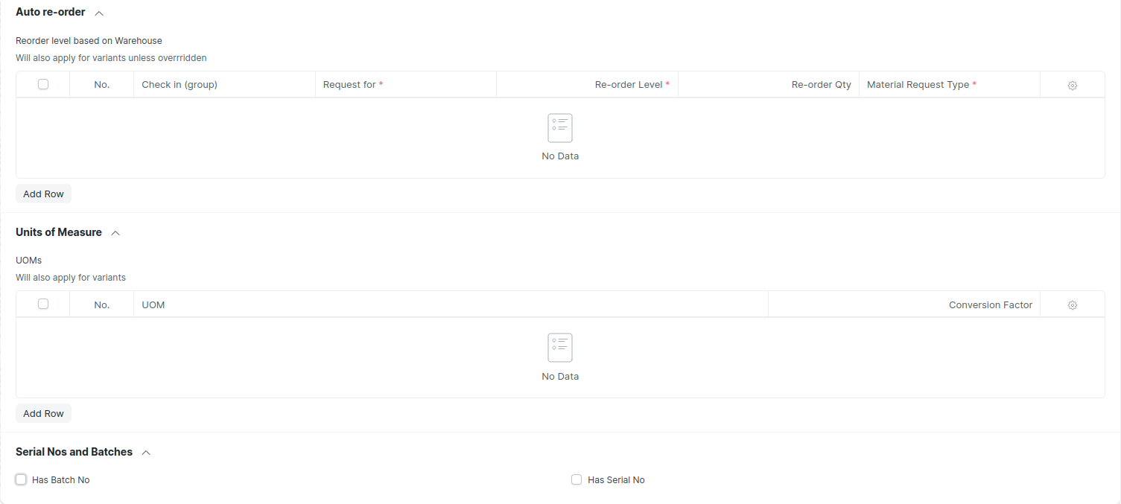

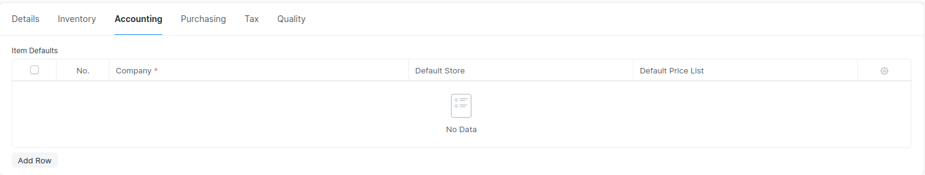

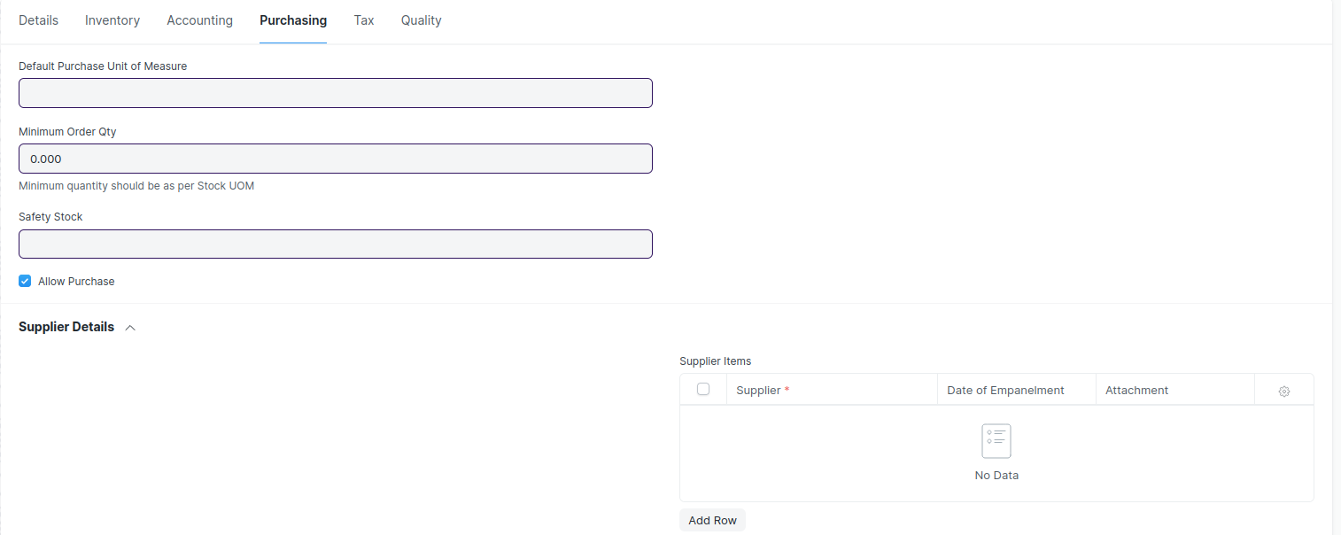

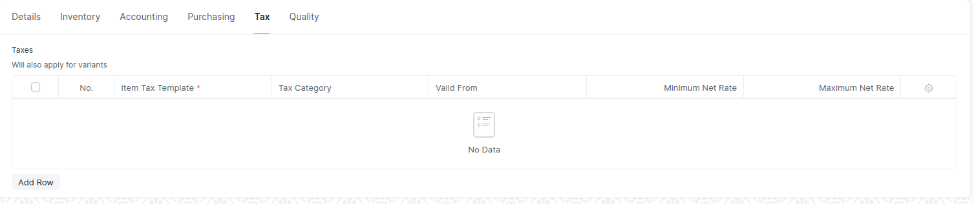

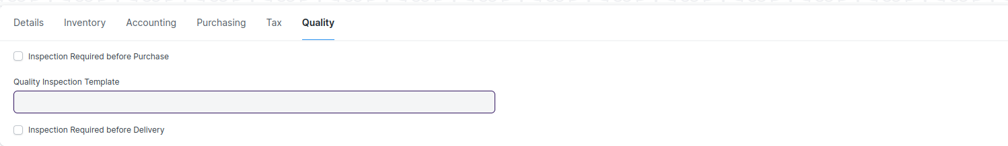

Figure : Item

## Item Price

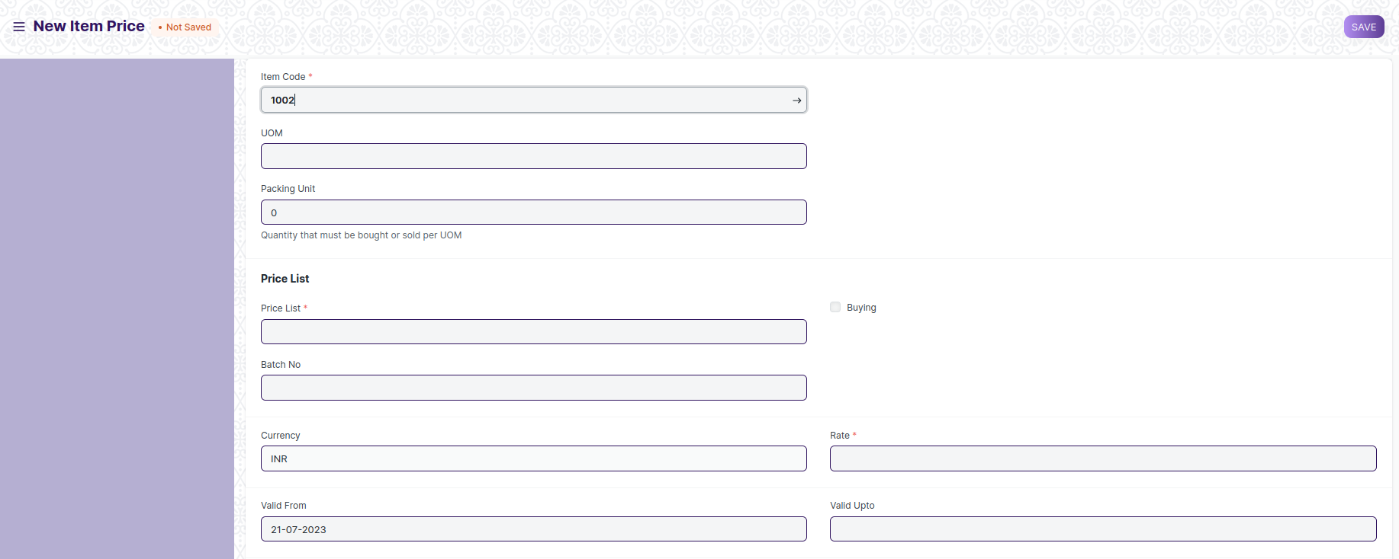

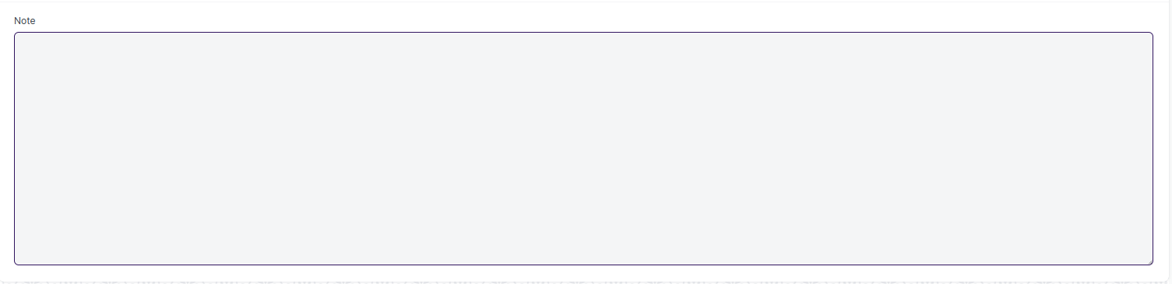

Figure : Item Price

## Price List

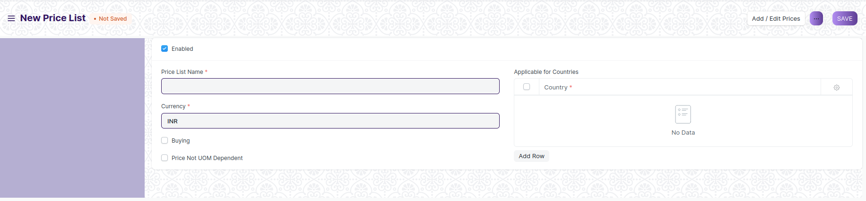

Figure : Price List

## Supplier

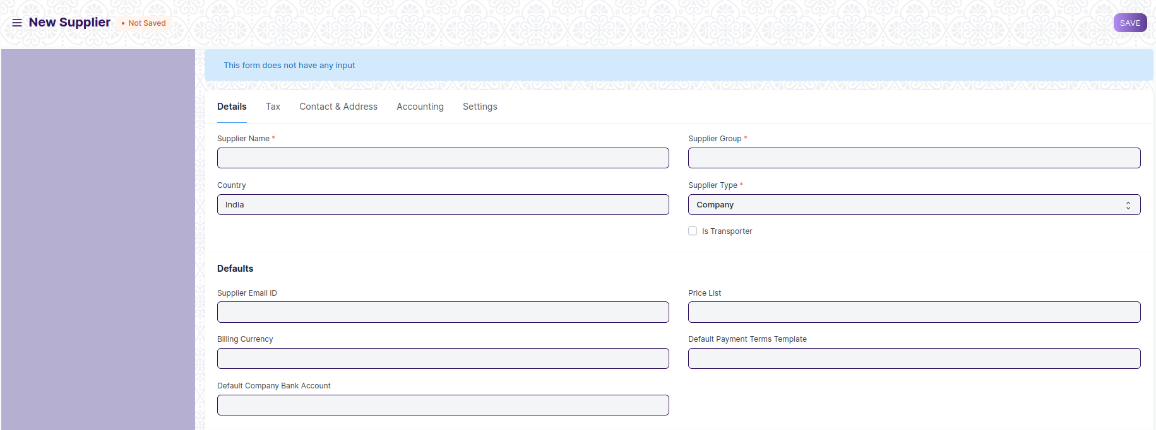

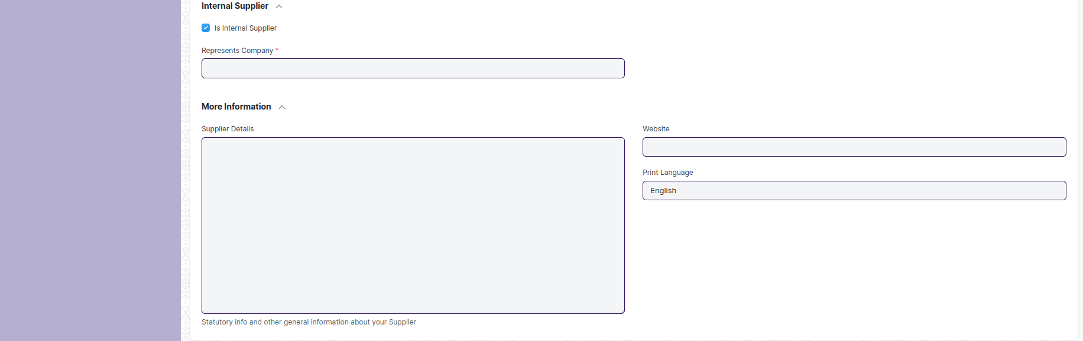

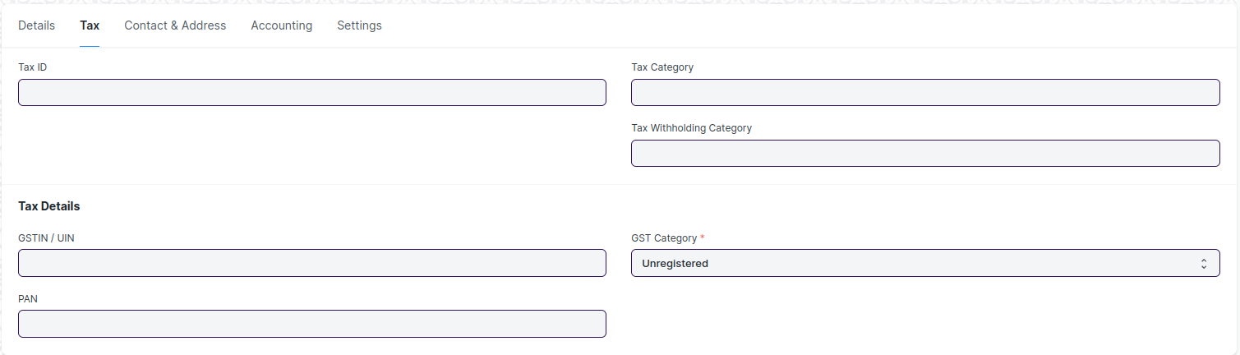

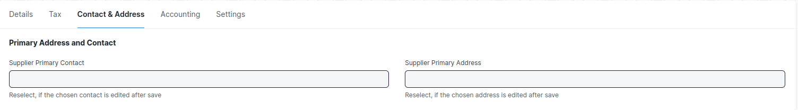

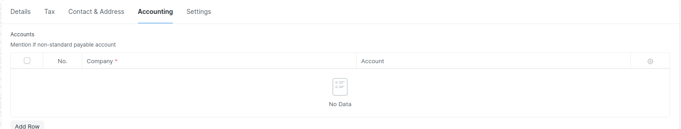

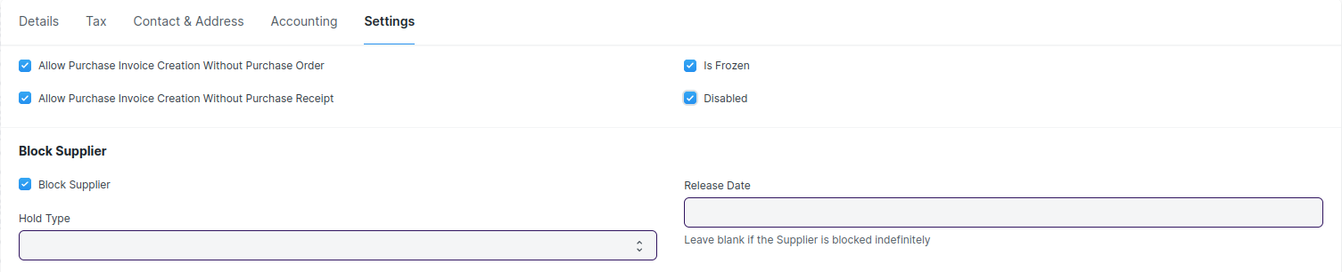

Figure : Supplier

## Supplier Group

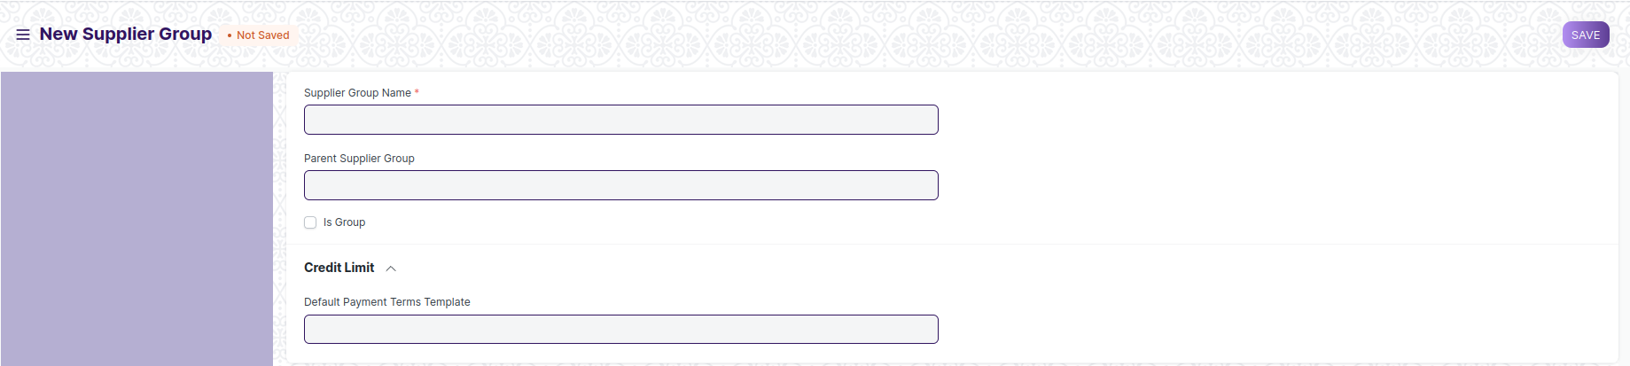

Figure : Supplier Group

## Quality Inspection Template

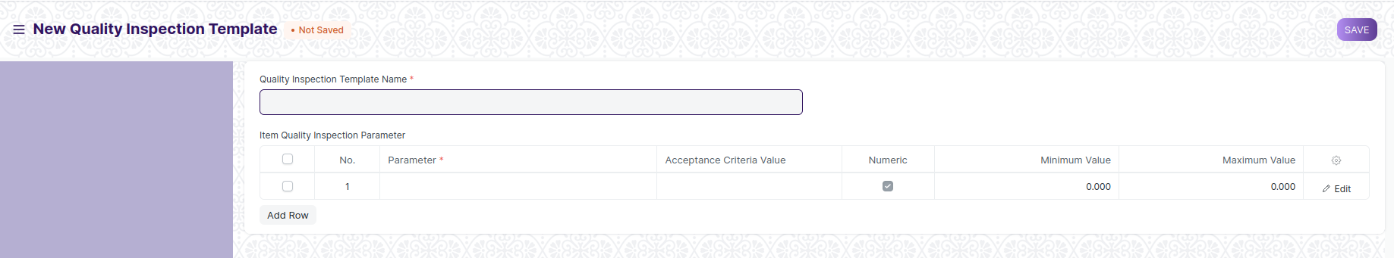

Figure : Quality Inspection Template

## Quality Inspection Parameter

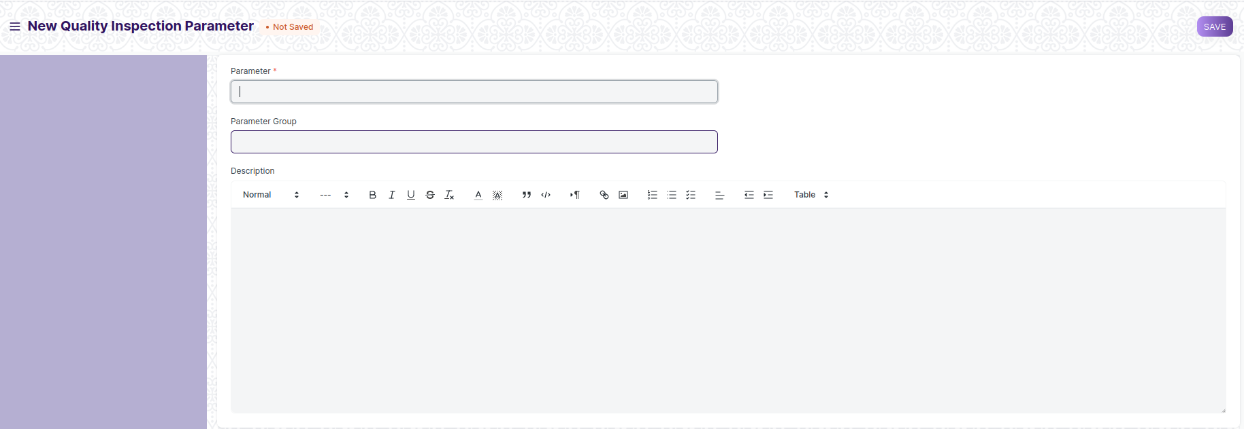

Figure : Quality Inspection Parameter

## Purchase Requisition

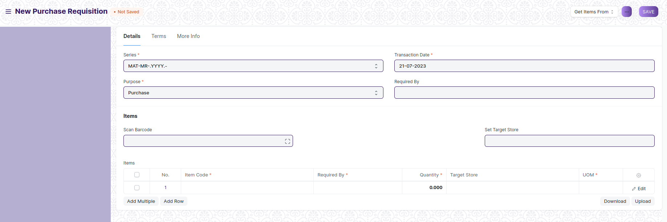

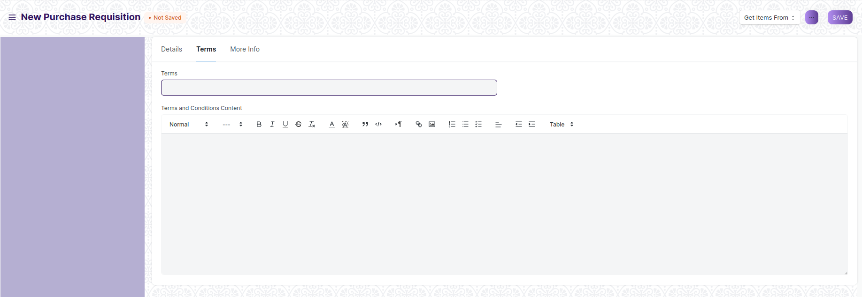

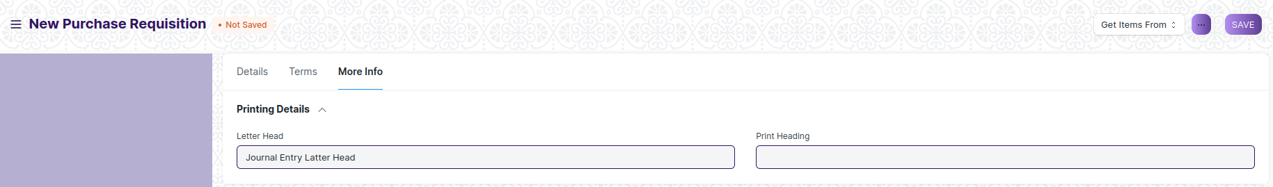

Figure : Purchase Requisition

## Request for Quotation

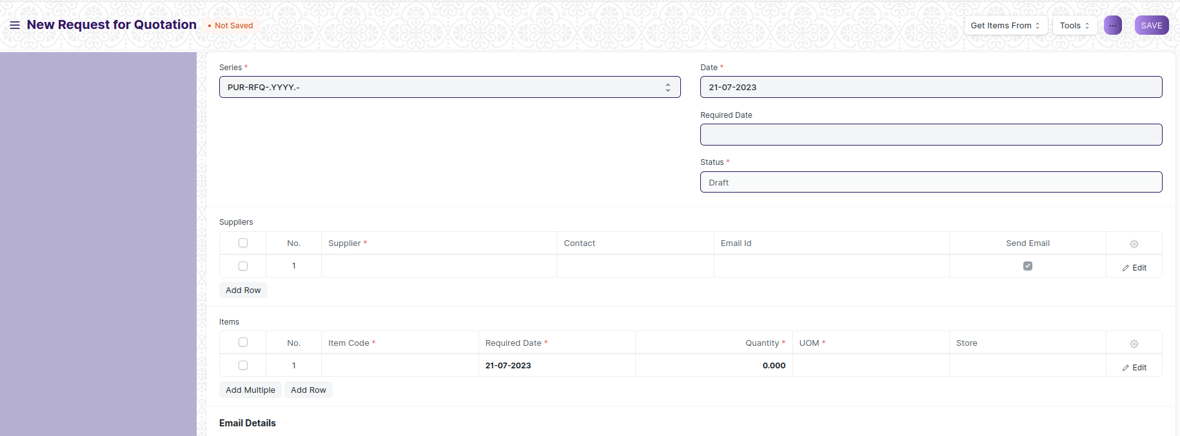

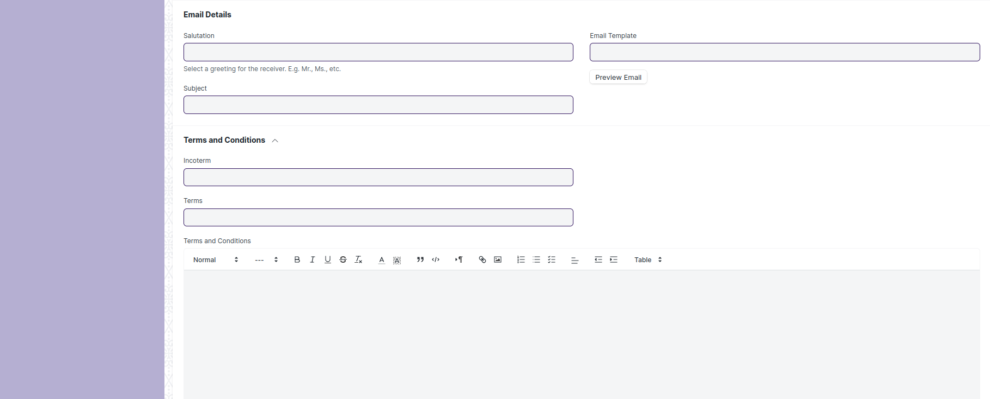

Figure : Request for Quotation

## Supplier Quotation

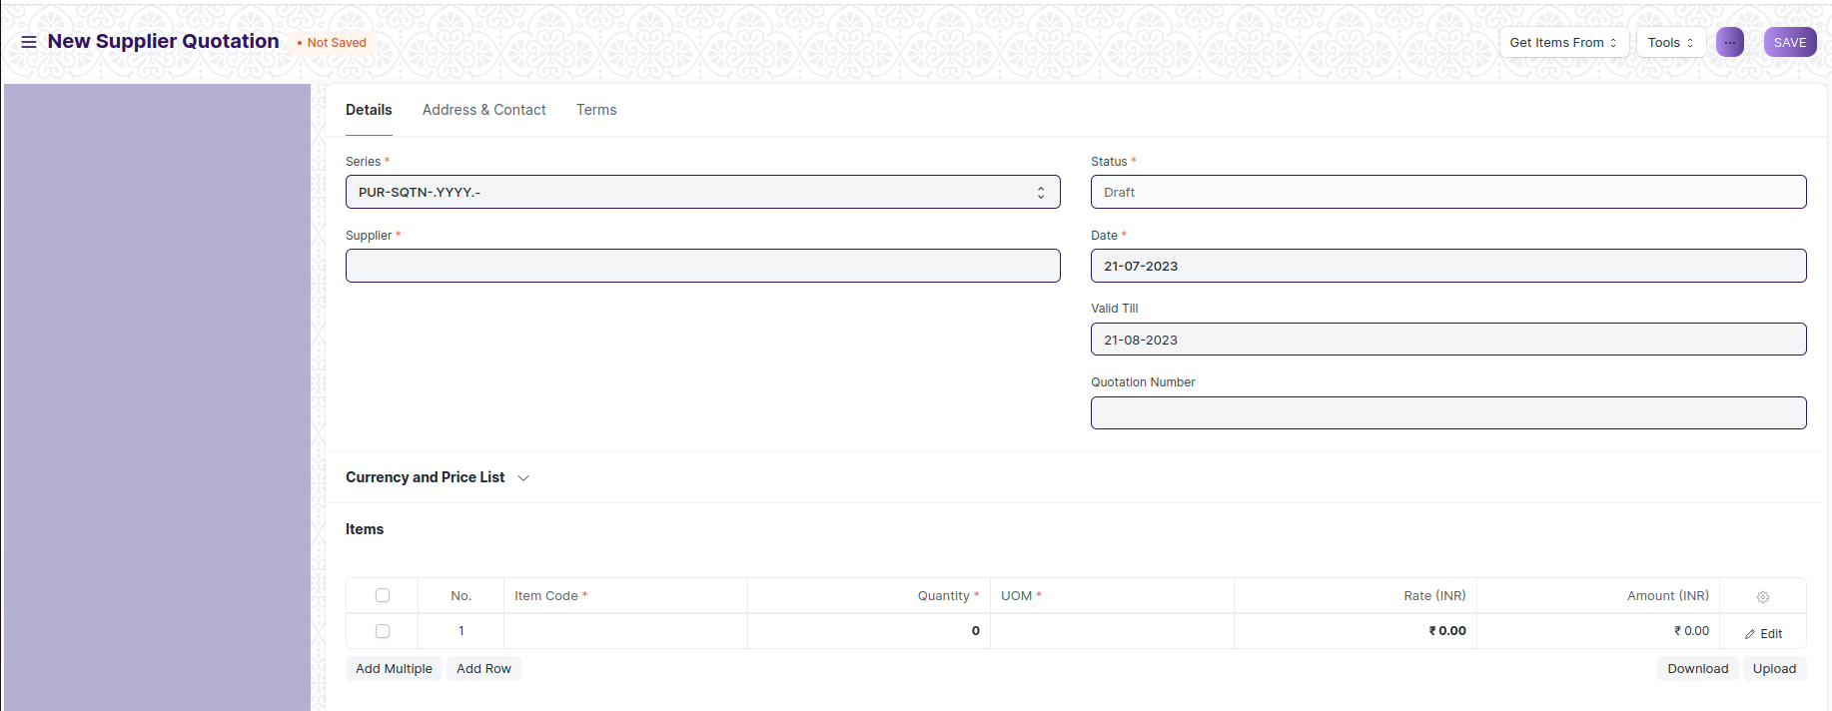

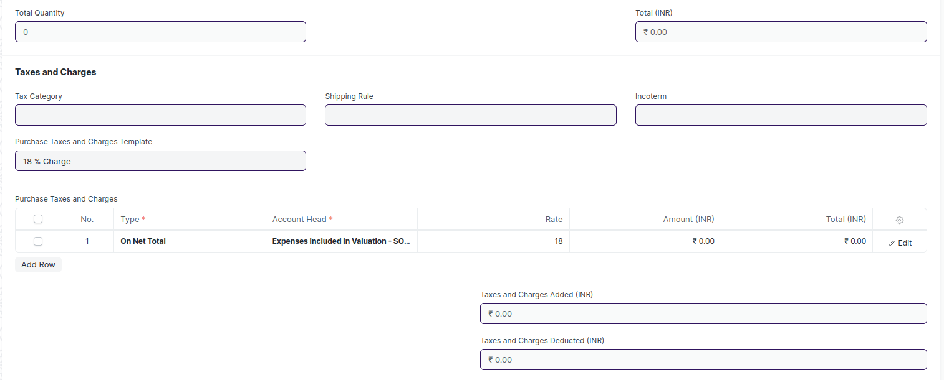

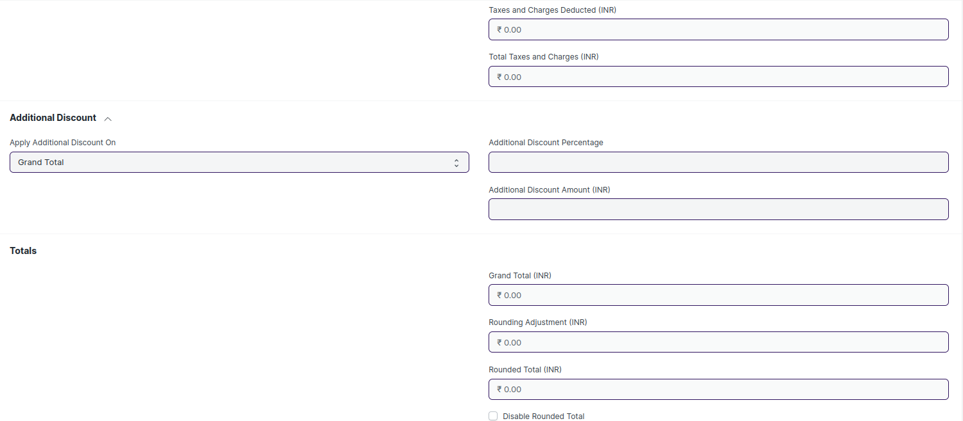



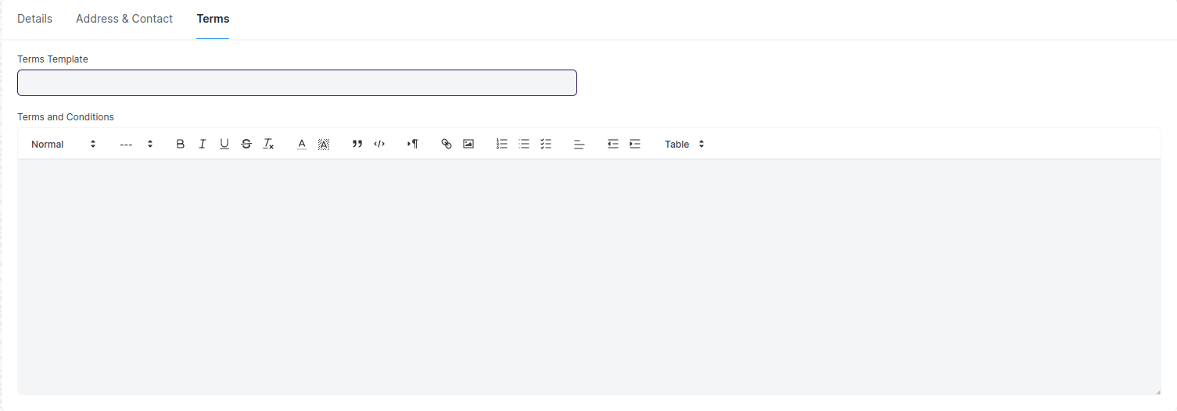

Figure : Supplier Quotation

## Purchase Order

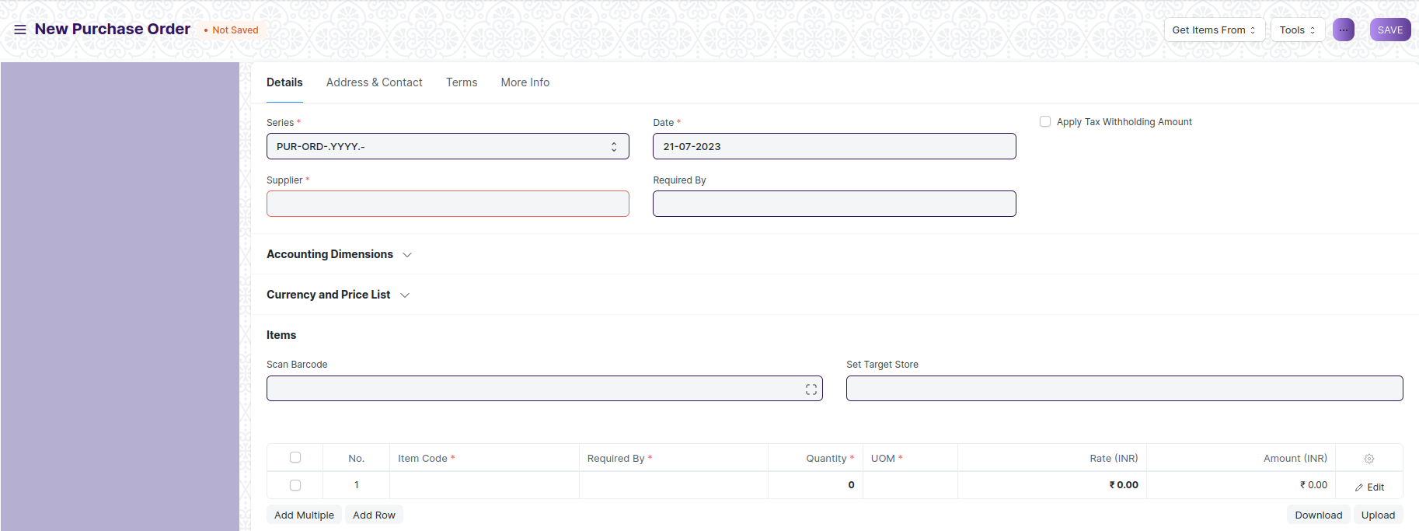

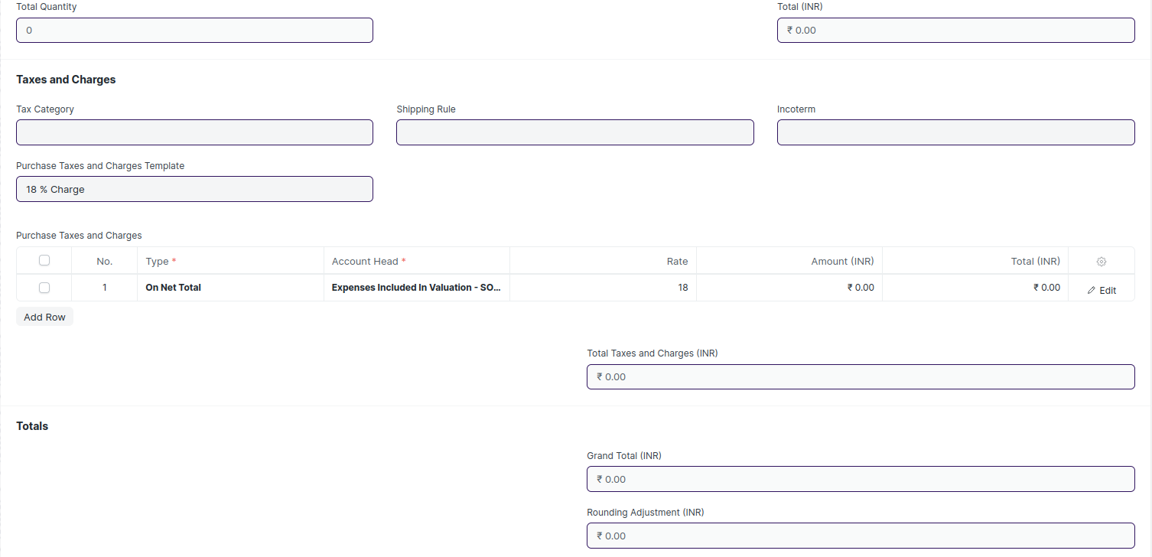

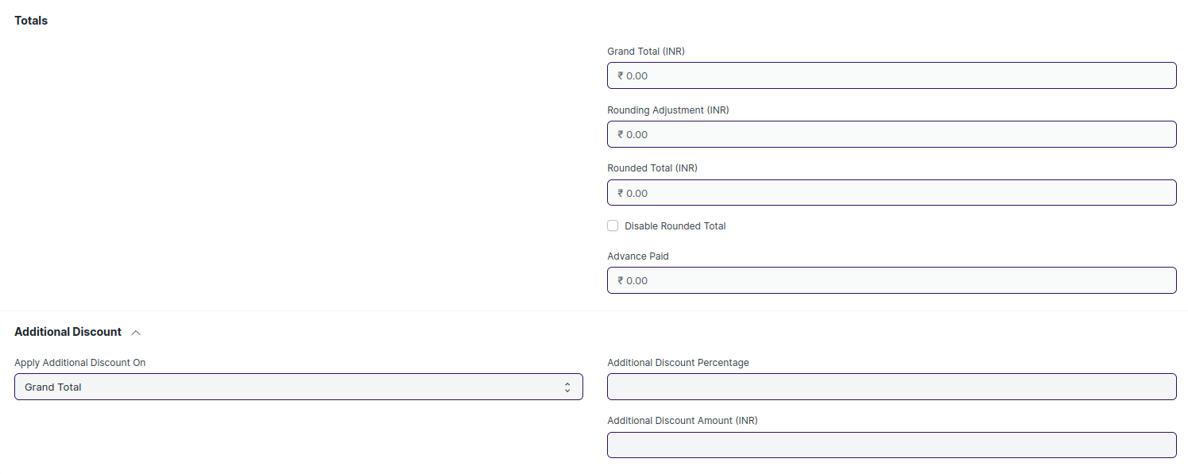

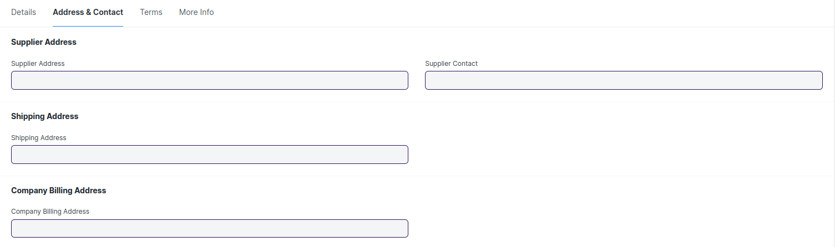

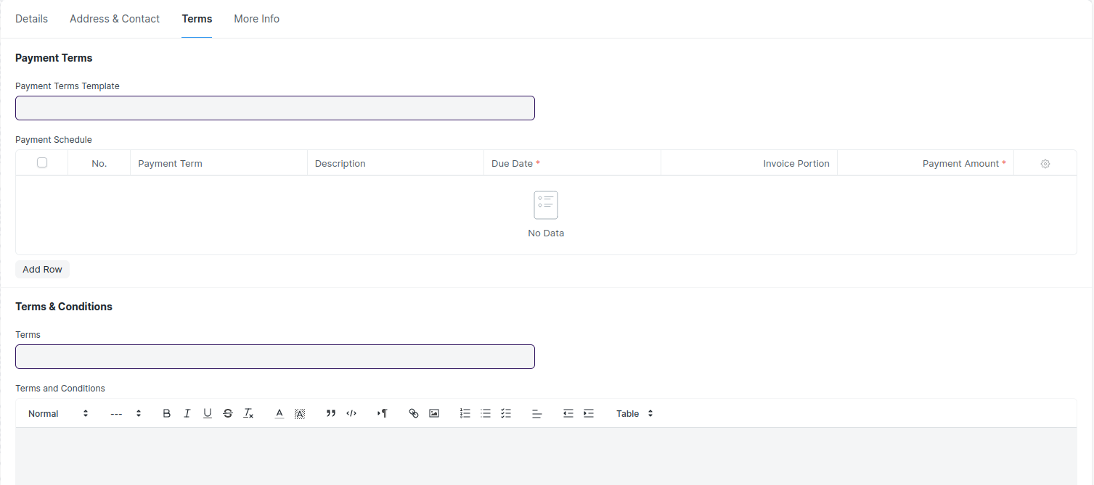

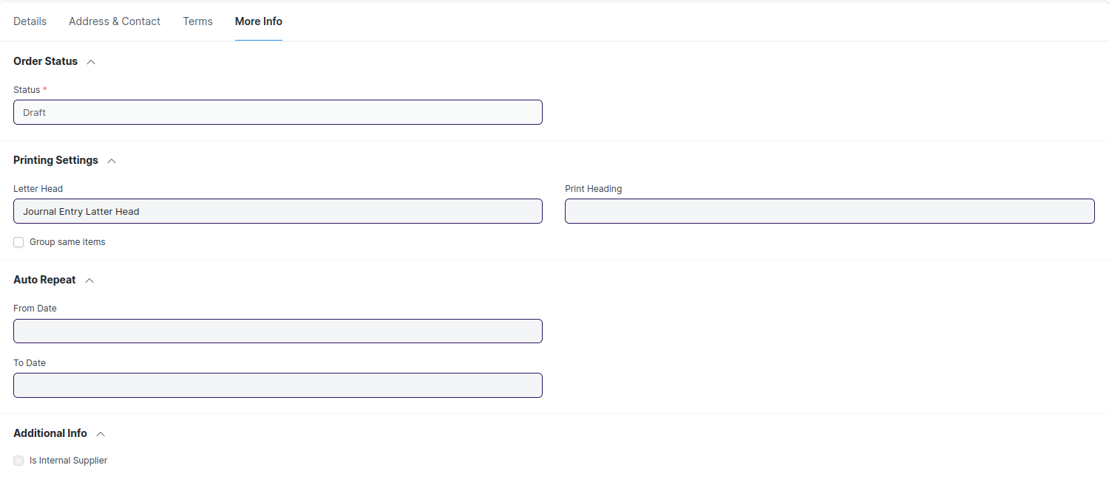

Figure : Purchase Order

## Purchase Receipt

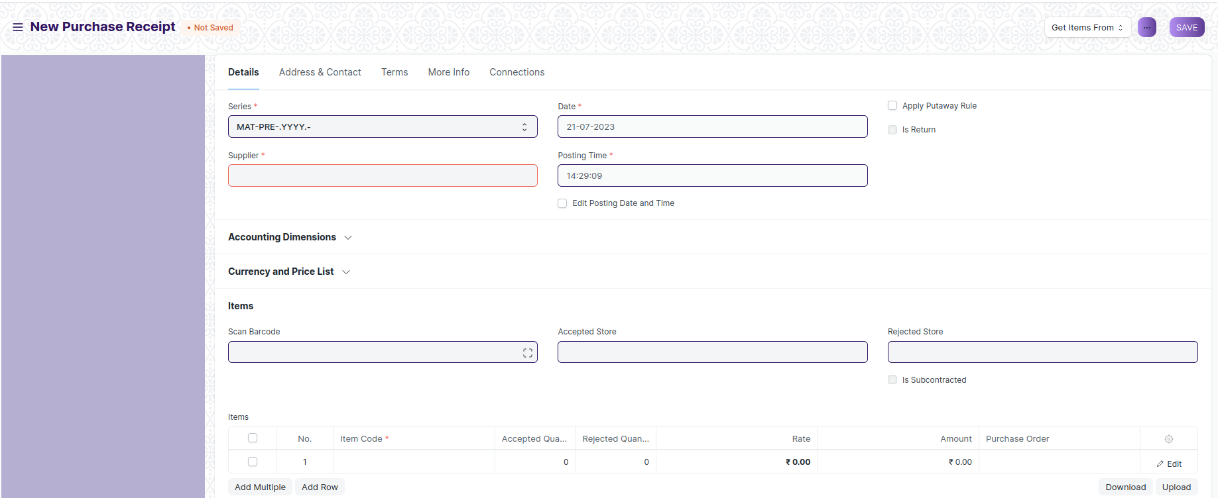

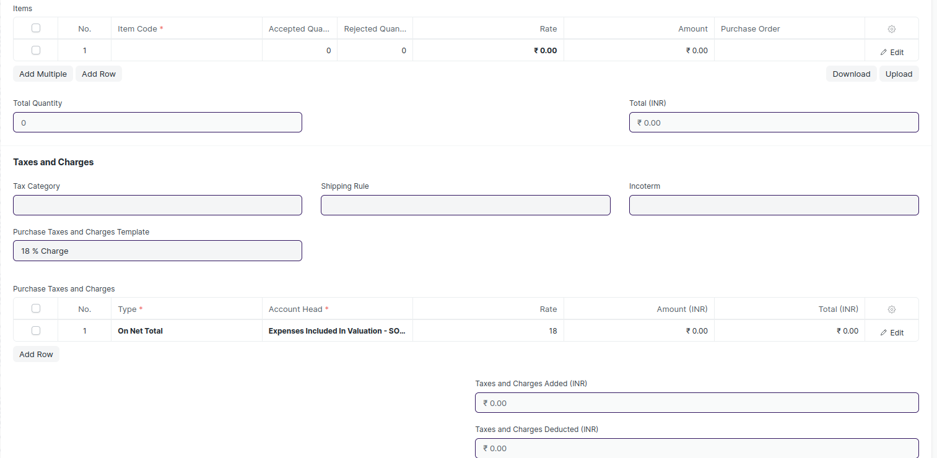

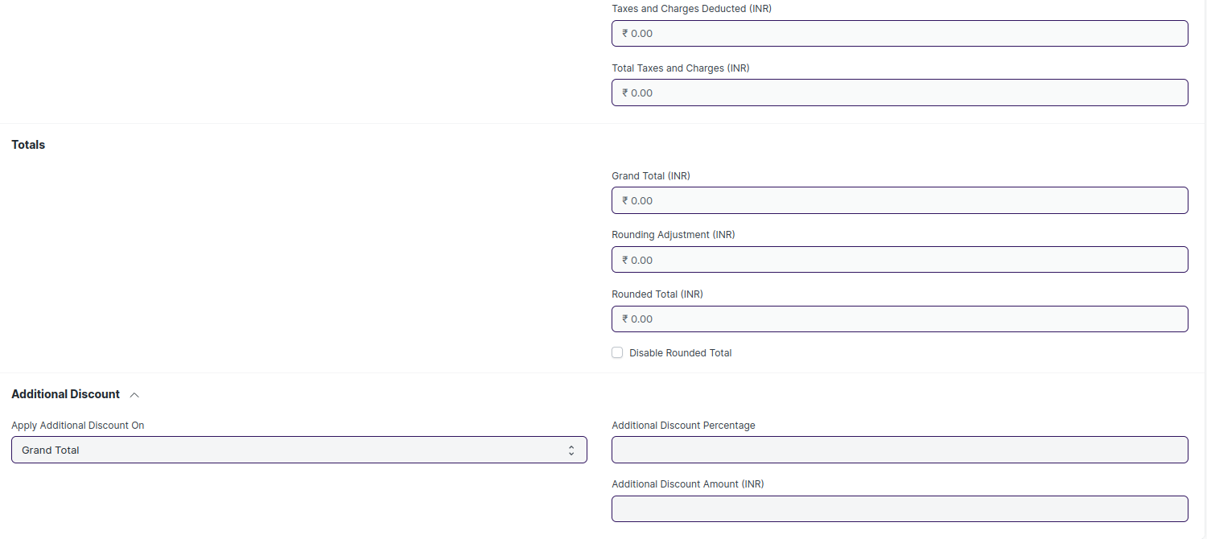

Figure : Purchase Receipt

## Purchase Invoice

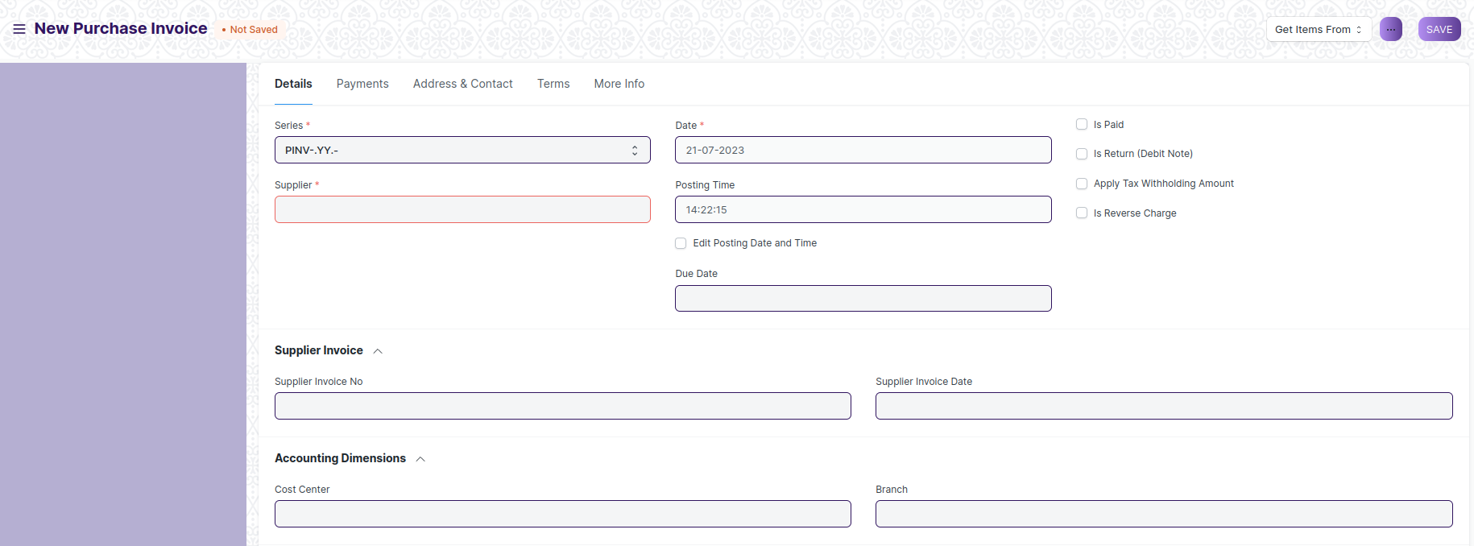

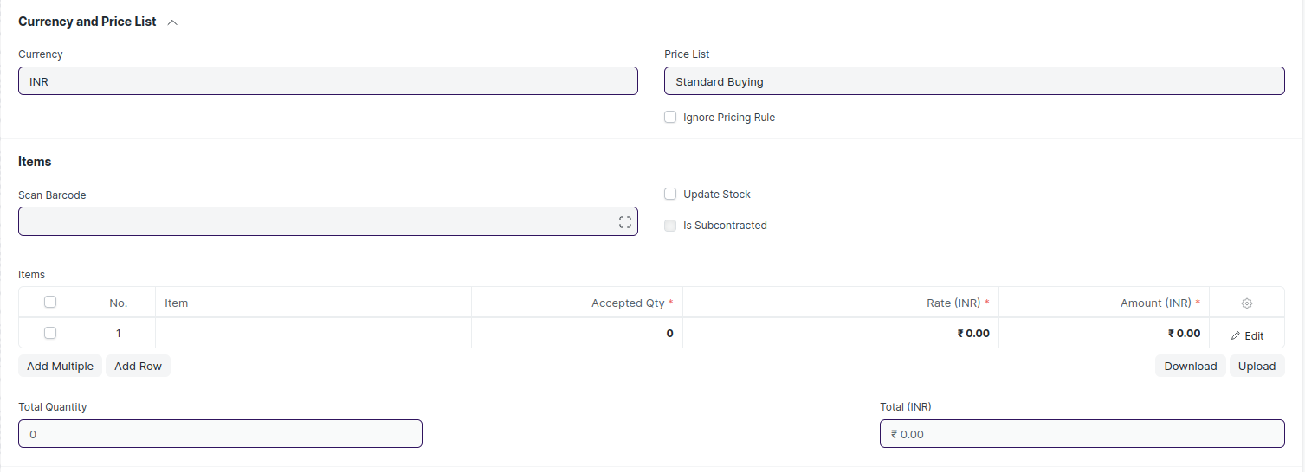

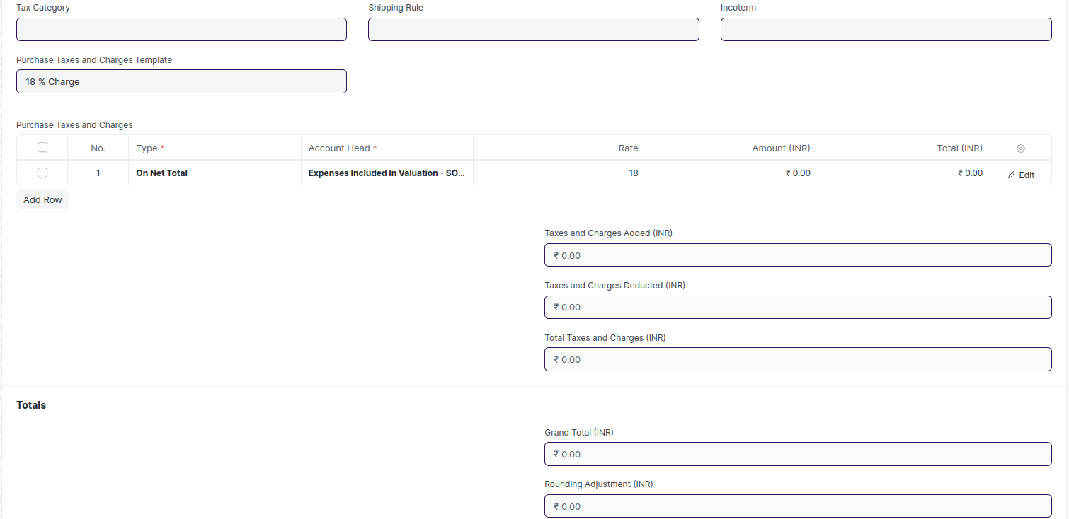

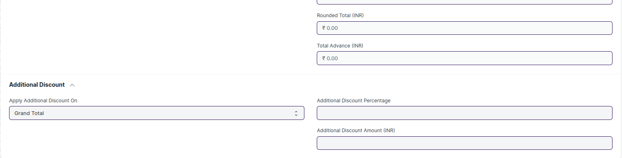

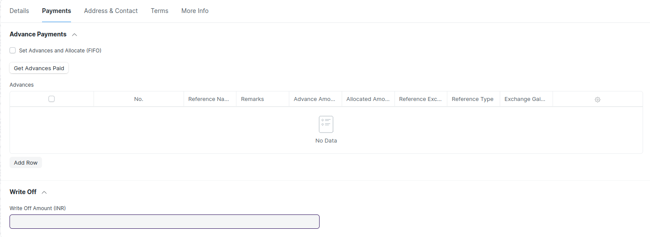

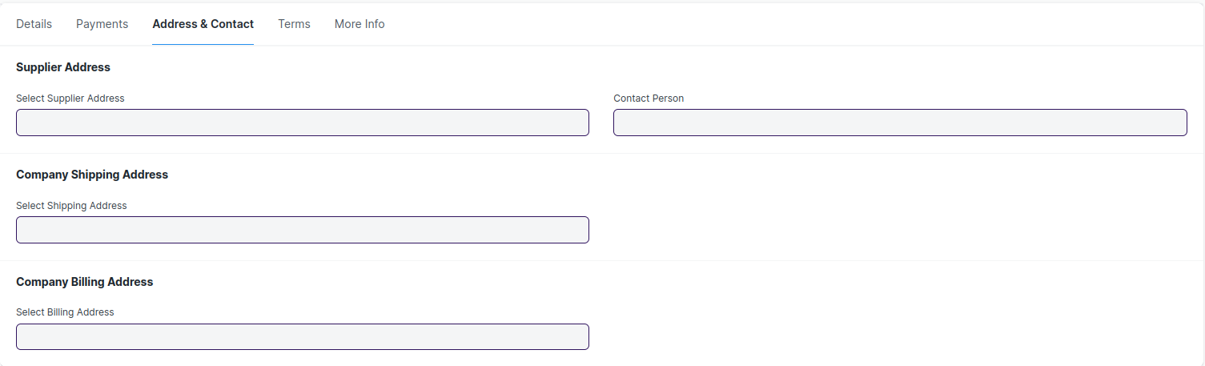

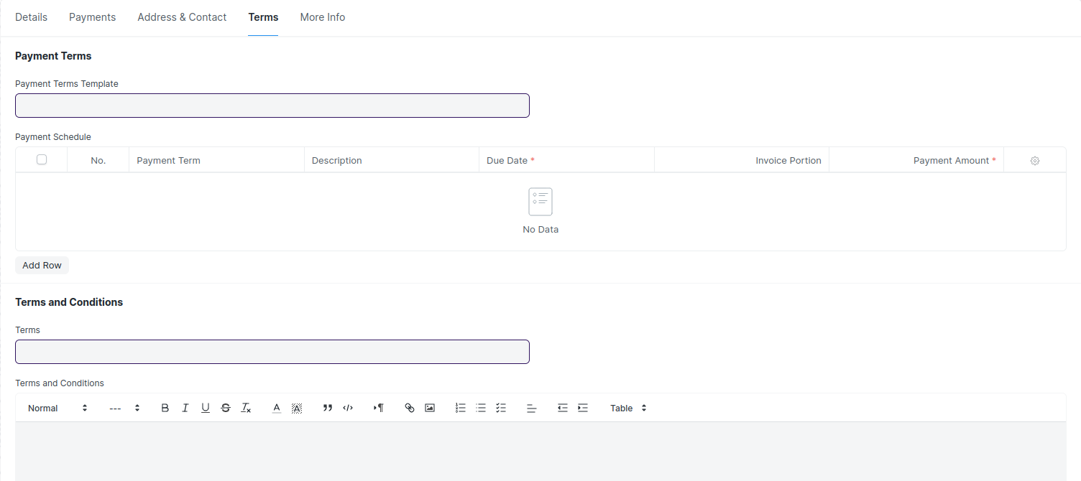

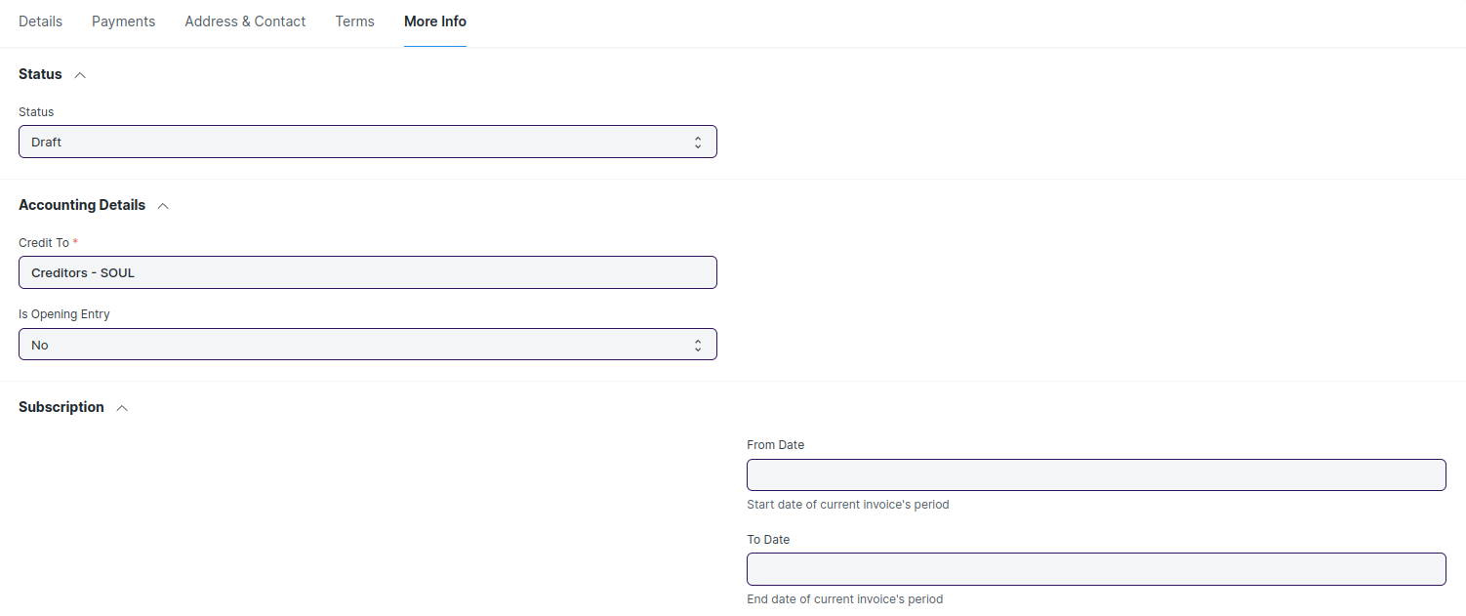

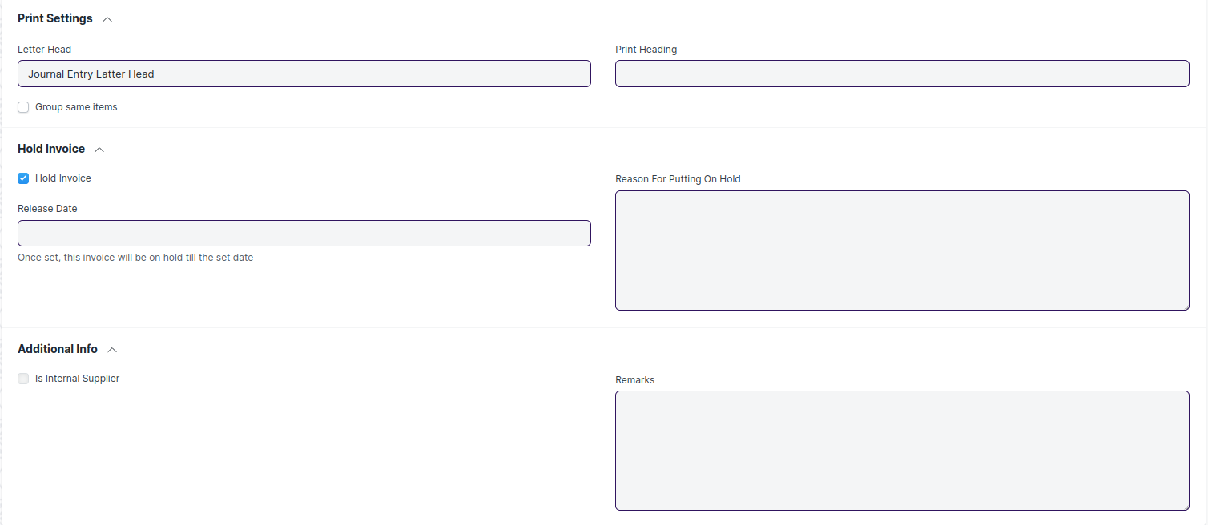

Figure : Purchase Invoice

## Stock Entry

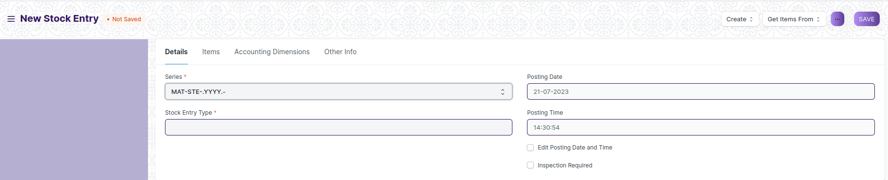

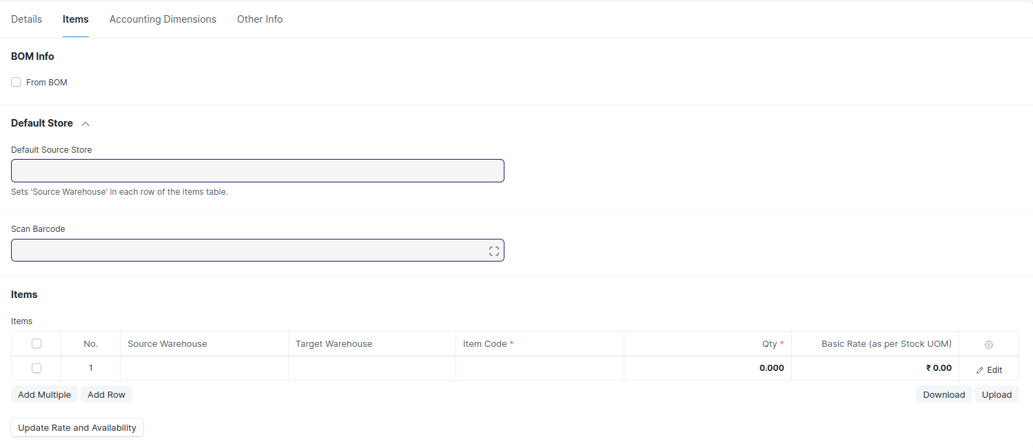

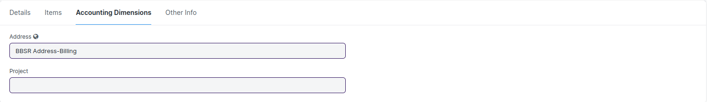

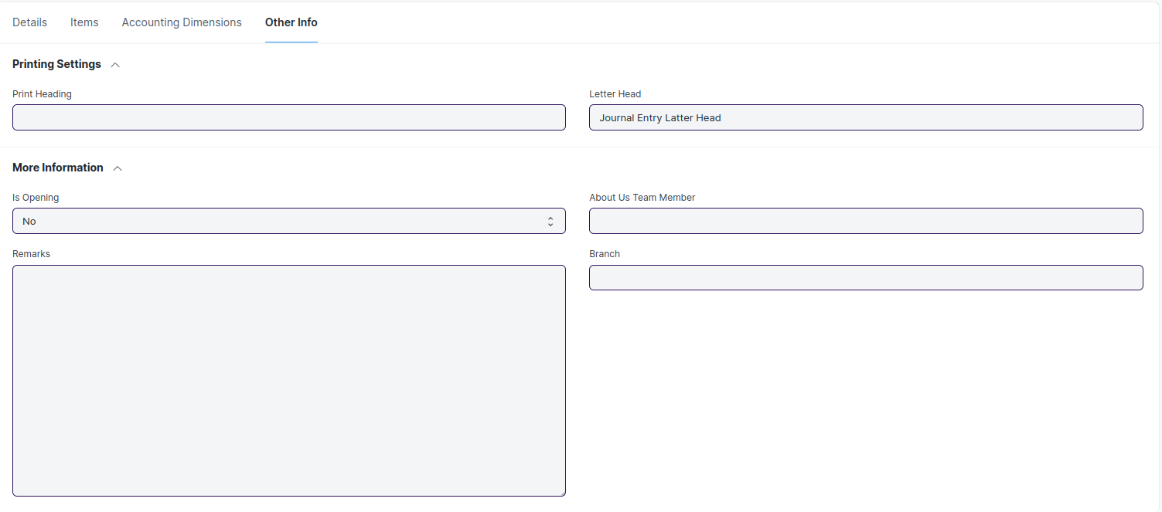

Figure : Stock Entry

## Stock Balance

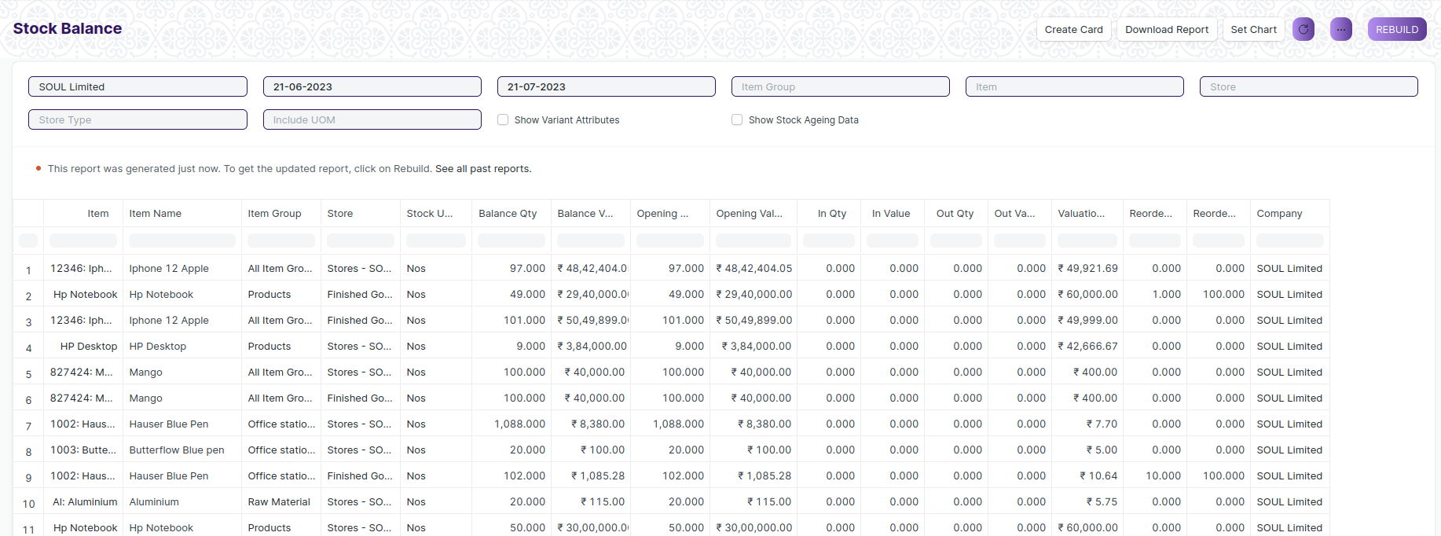

Figure : Stock Balance

## Stock Ledger

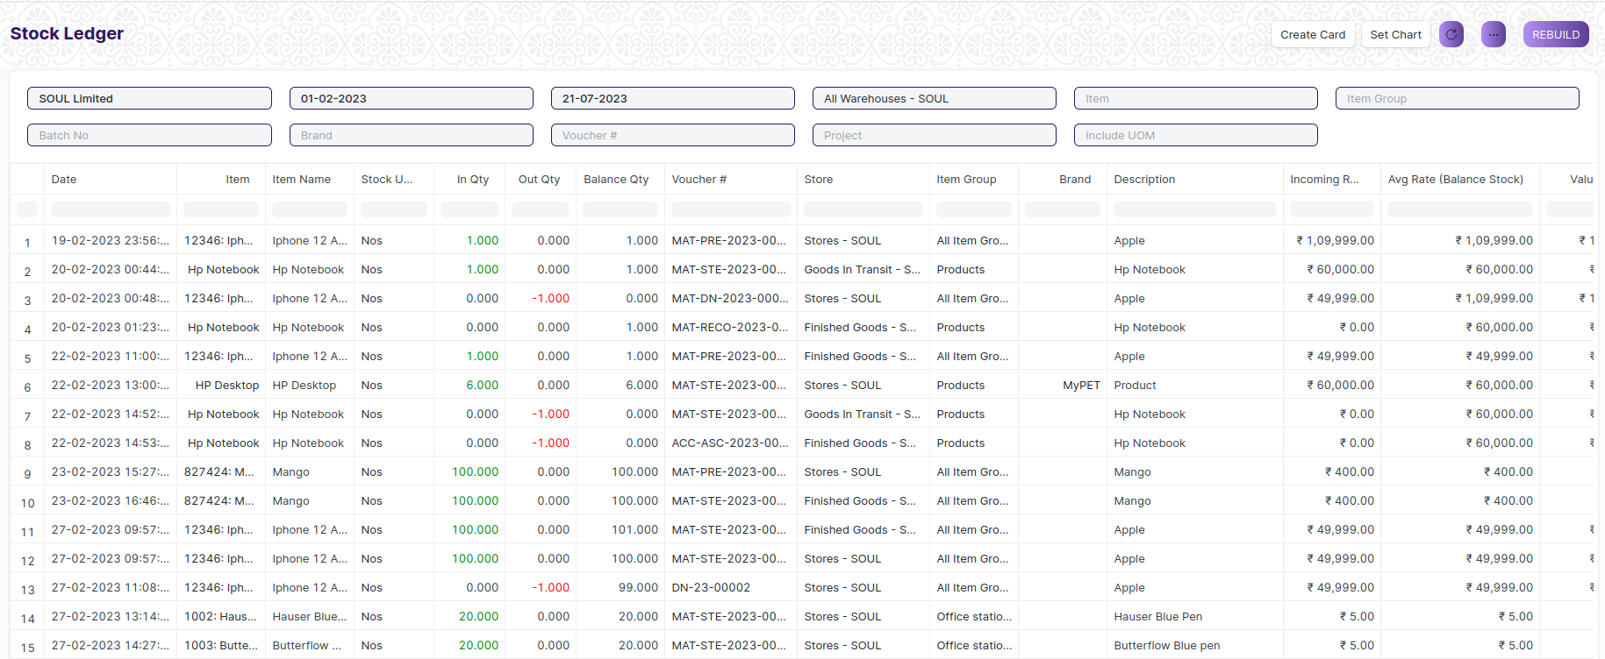

Figure : Stock Ledger

## Stock Summary

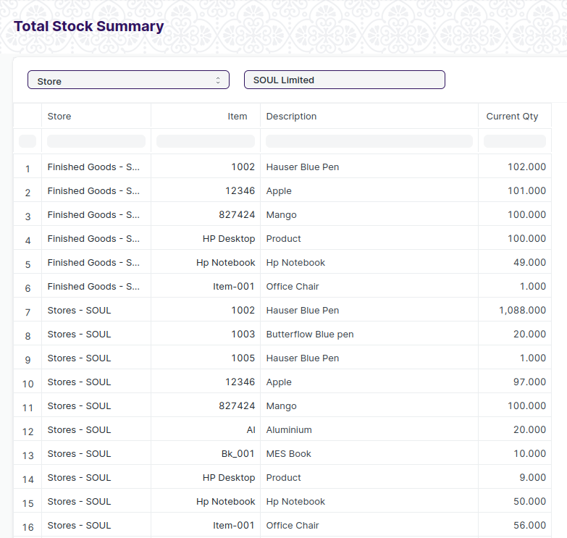

Figure : Stock Summary

## Stock Setting

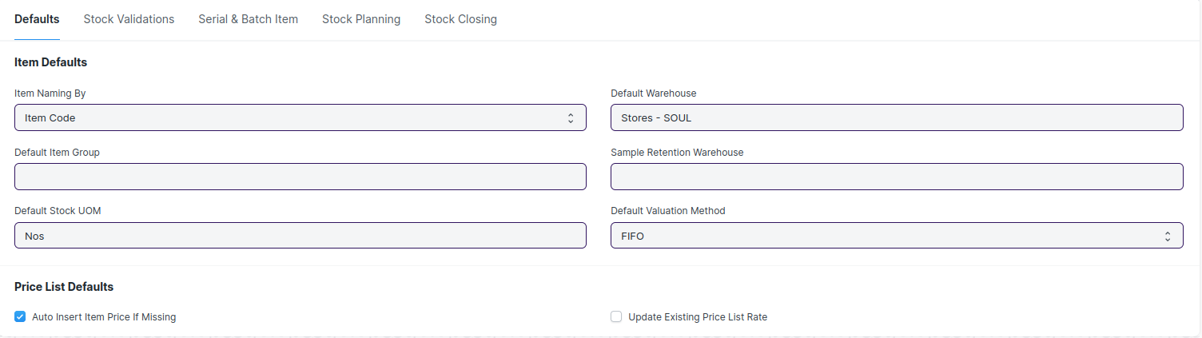

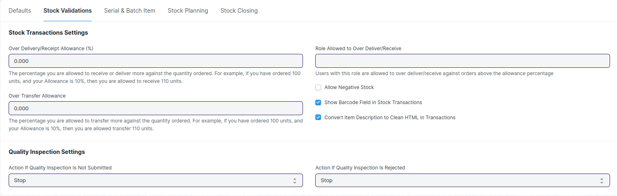

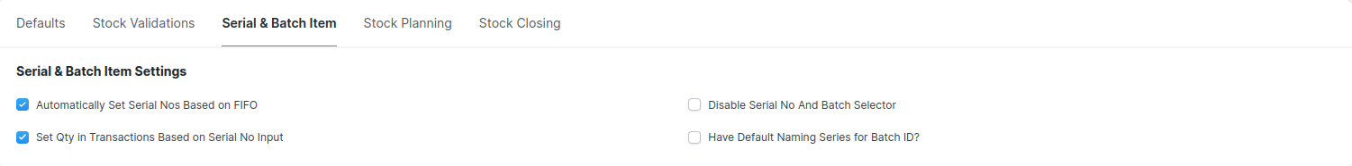

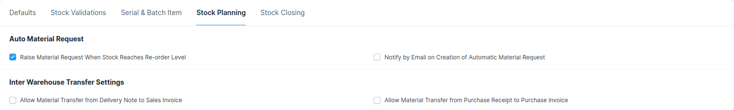

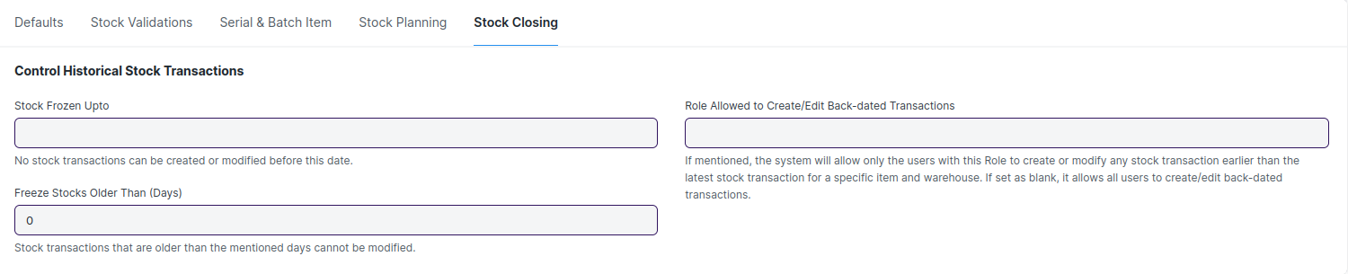

Figure : Stock Setting

## Asset

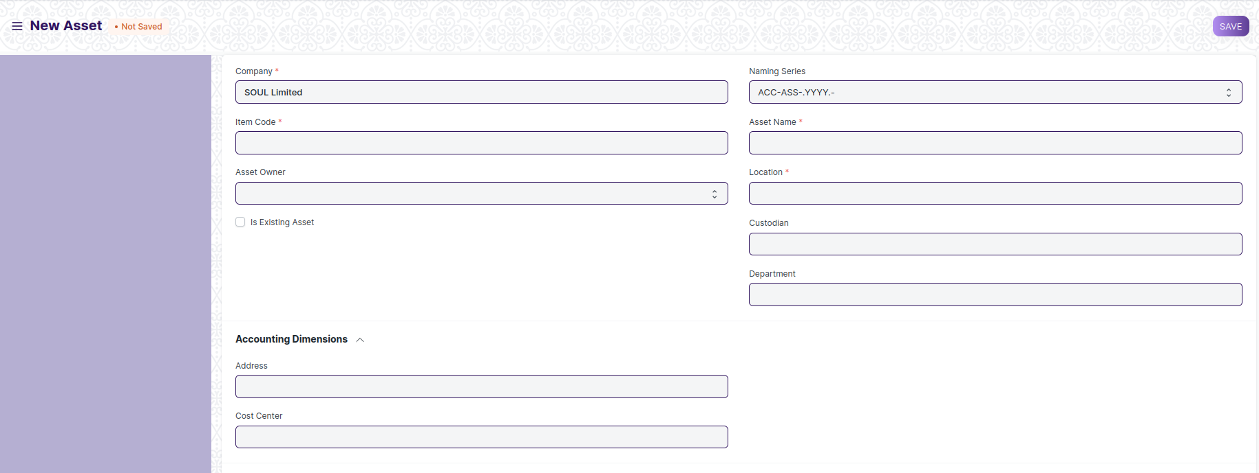

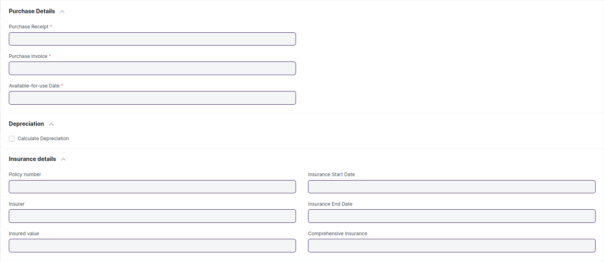

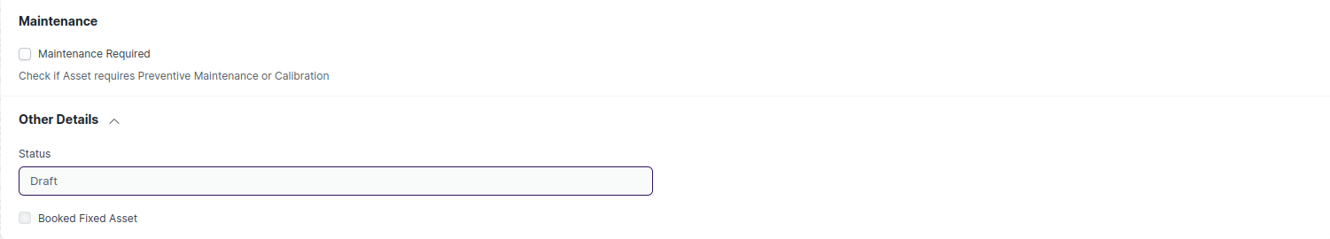

Figure : Asset

## Location

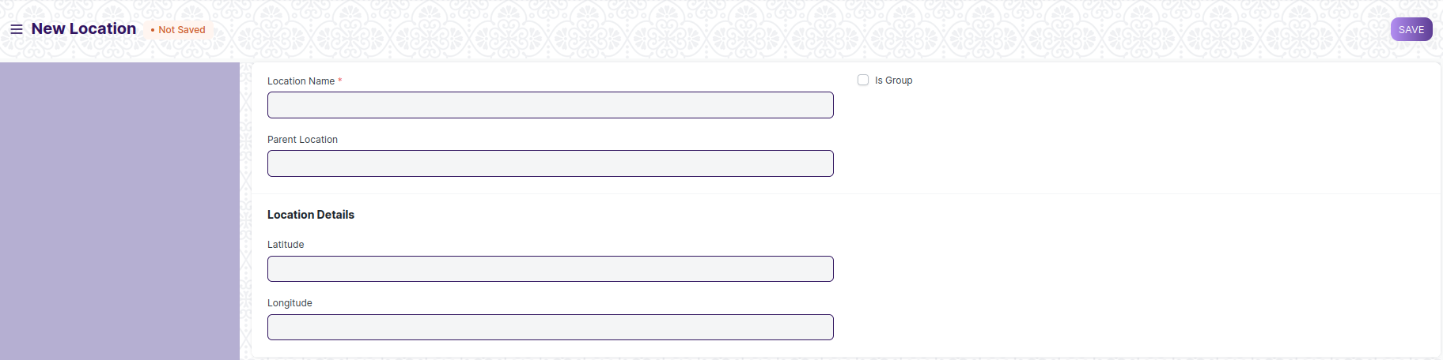

Figure : Location

## Asset Category

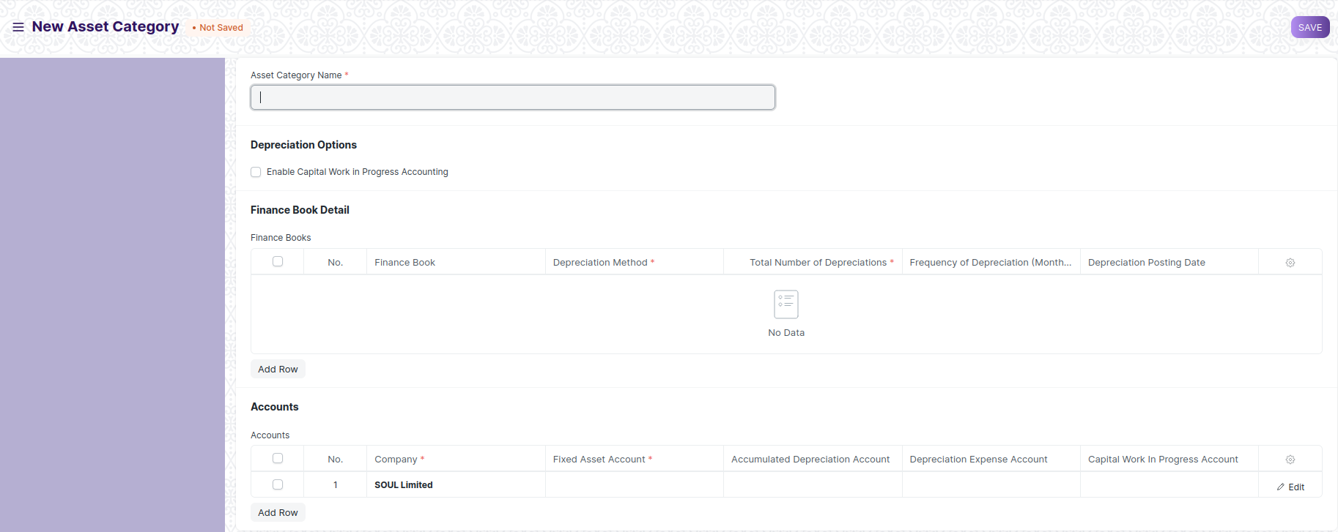

Figure : Asset Category

## Asset Movement

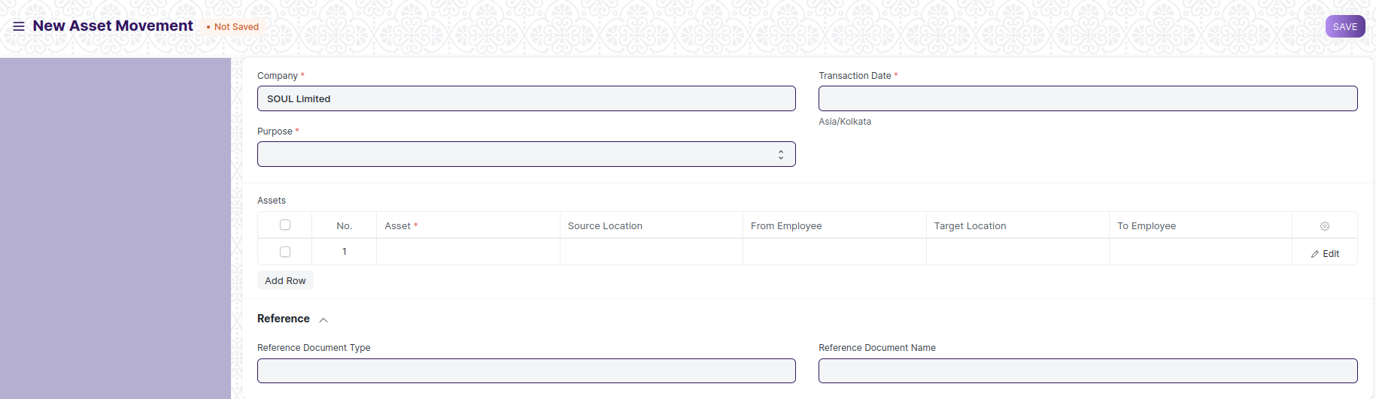

Figure : Asset Movement

## Asset Maintenance Team

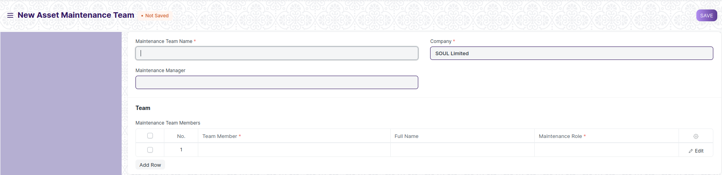

Figure : Asset Maintenance Team

## Asset Maintenance

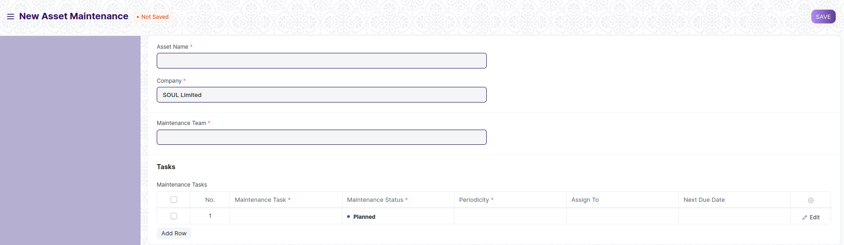

Figure : Asset Maintenance

## Asset Maintenance Log

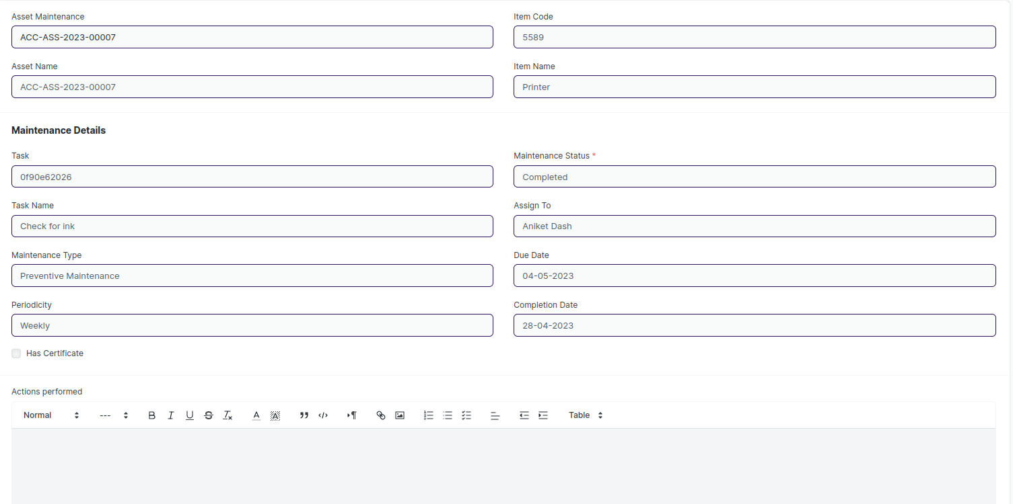

Figure : Asset Maintenance Log

## Asset Repair

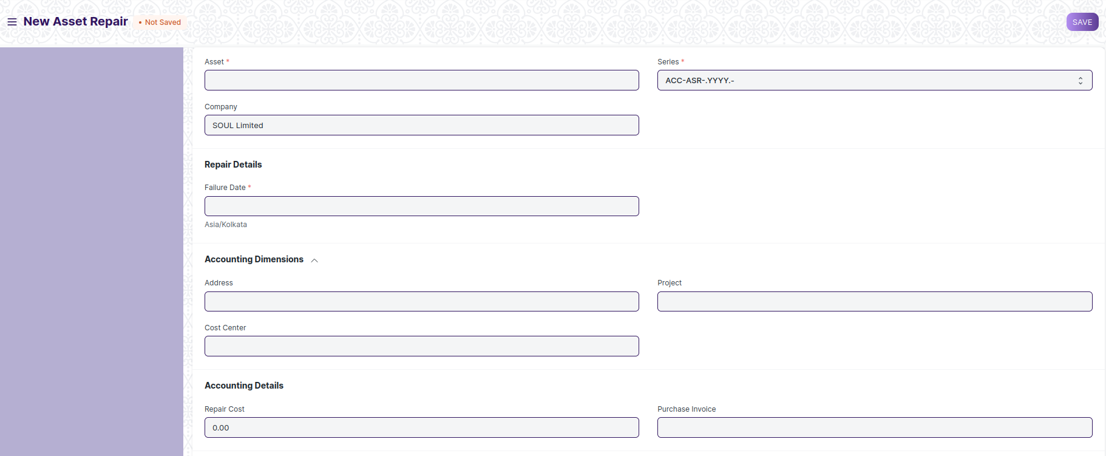

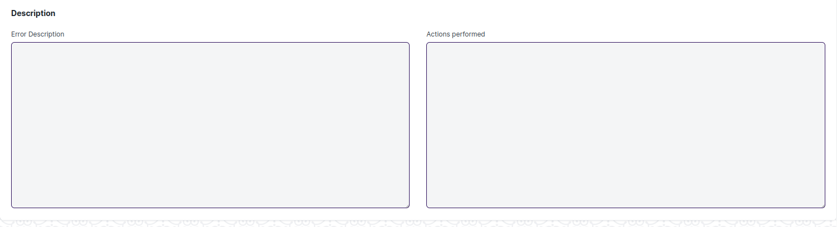

Figure : Asset repair

## Serial Number

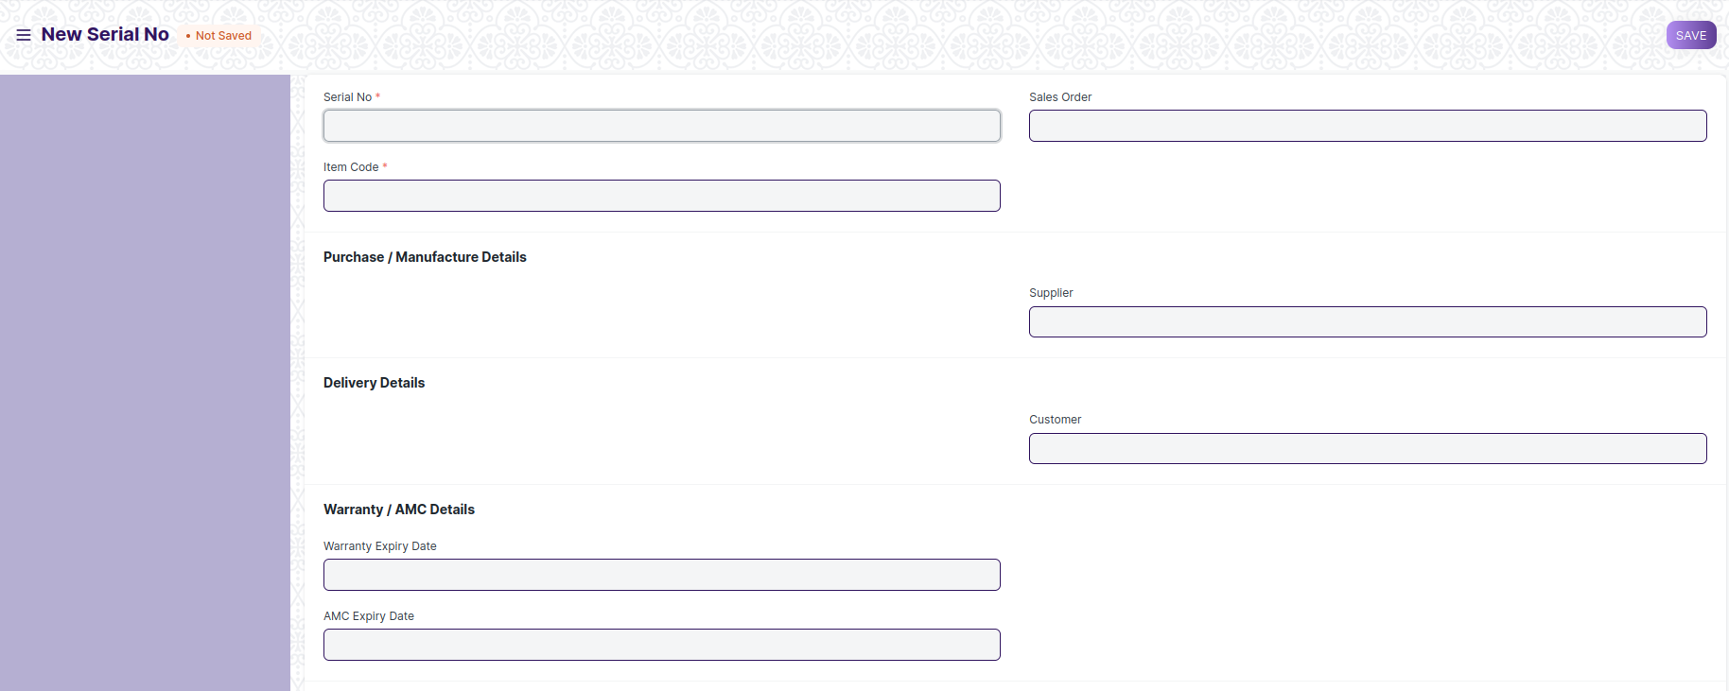

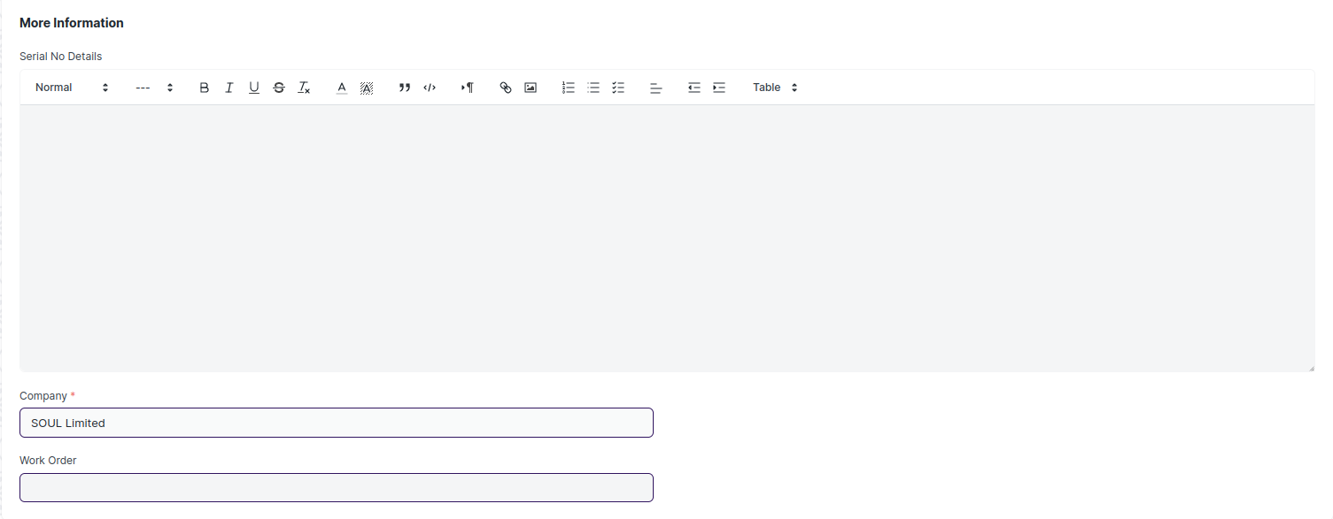

Figure : Serial number

## Batch Number

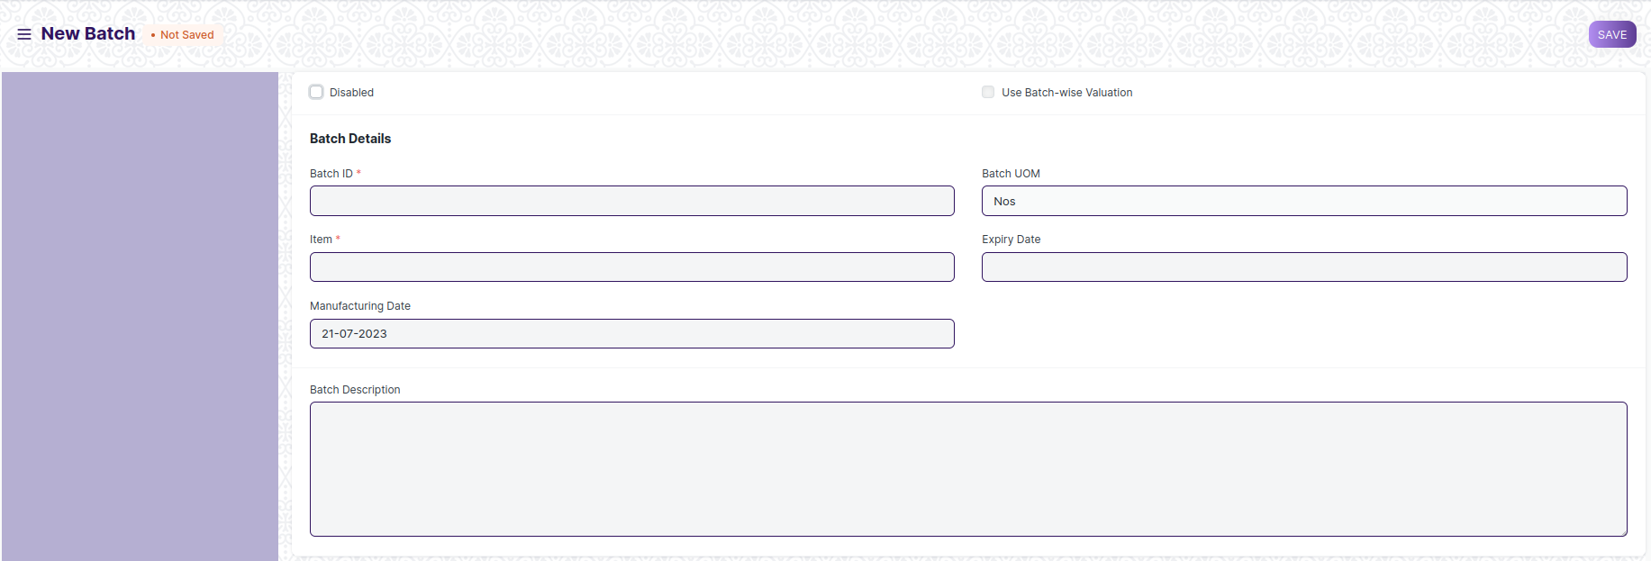

Figure : Batch number

## Store

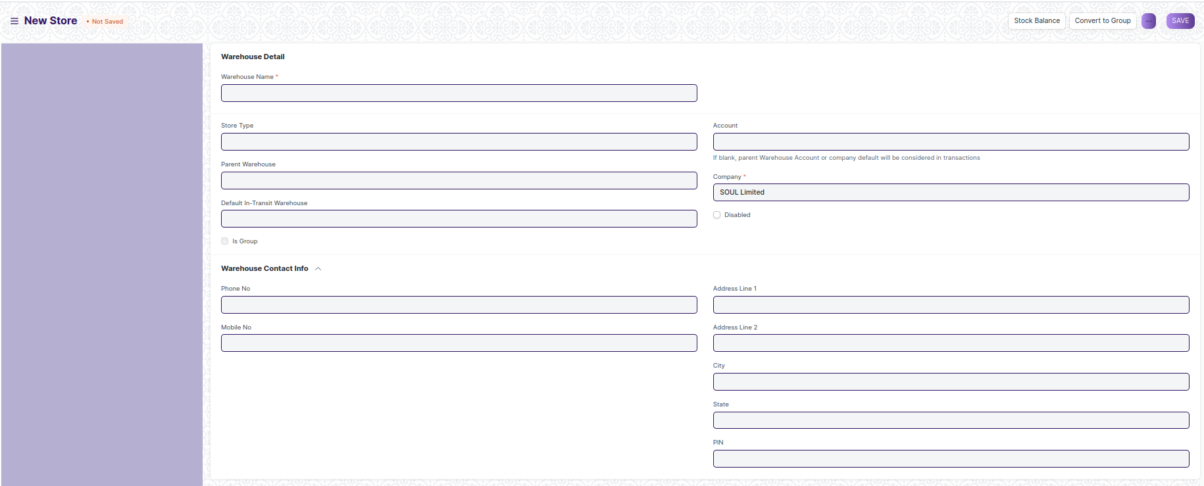

Figure : Store

## Unit of Measure (UOM)

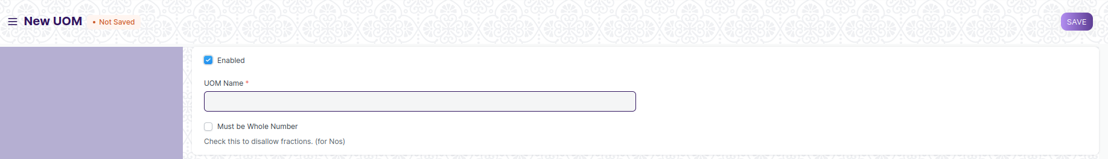

Figure : Unit of Measure

## Purchase Taxes and charges Template

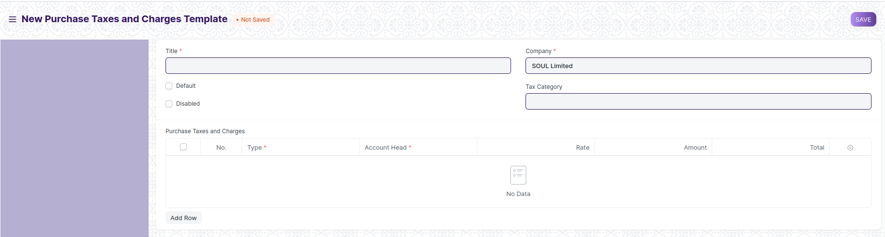

Figure : Purchase Taxes and Charges Template

## Tax Category

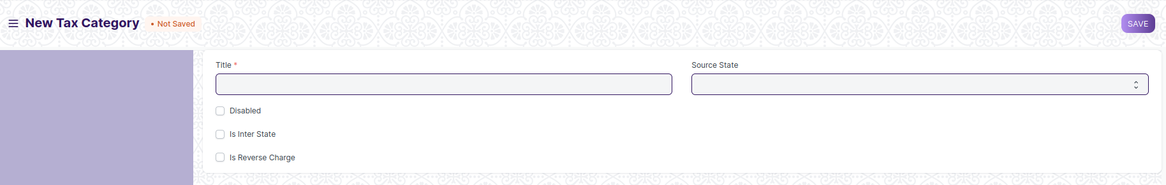

Figure : Tax category

## Terms and Conditions Template

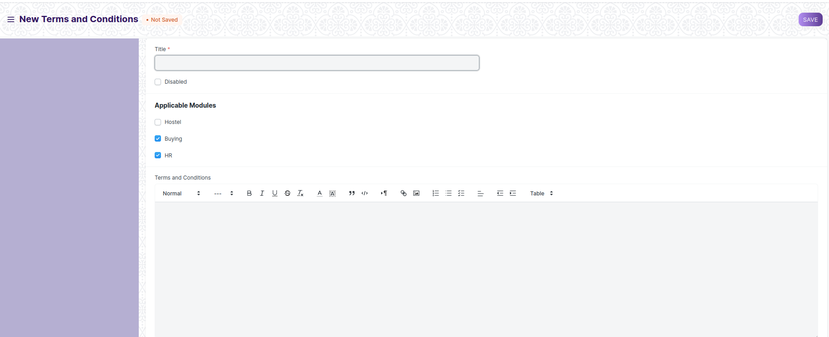

Figure : Terms and Conditions Template

## Buying Setting

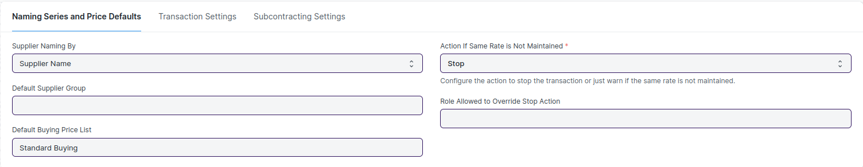

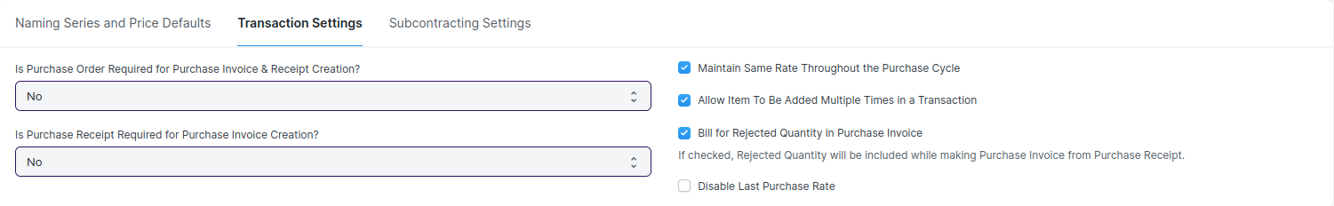

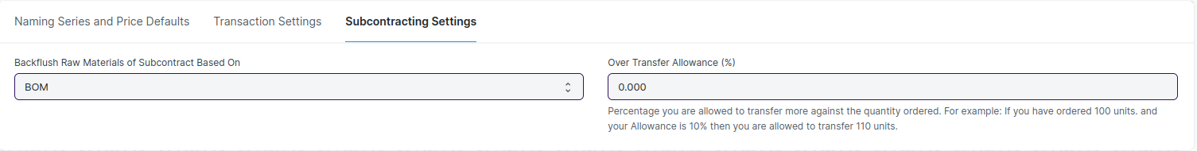

Figure : Buying setting

## Payment Terms Template

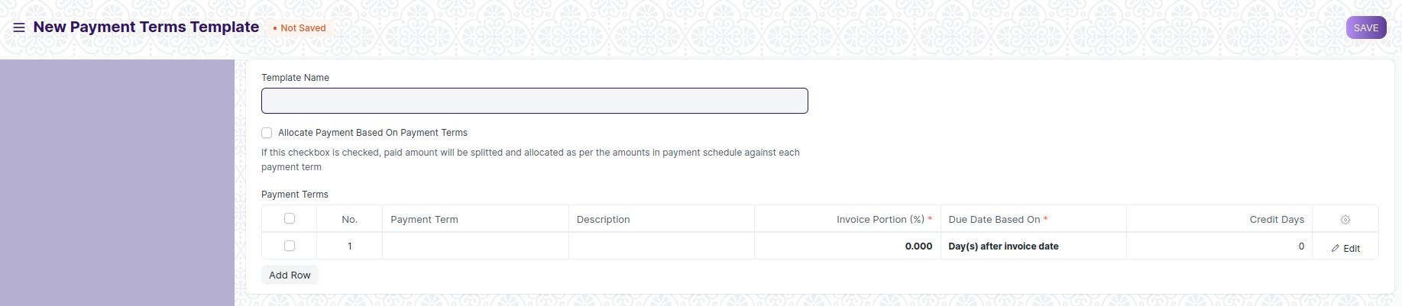

Figure : Payment Terms Template

## Tax Withholding Category

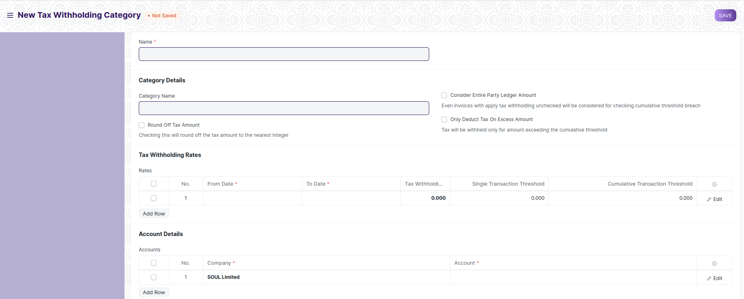

Figure : Tax Withholding category

## L1 Vendor selection report

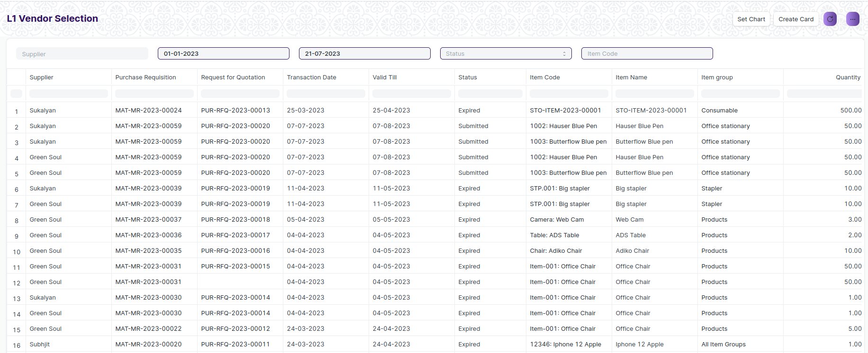

Figure : L1 Vendor selection report

## Asset Summary report

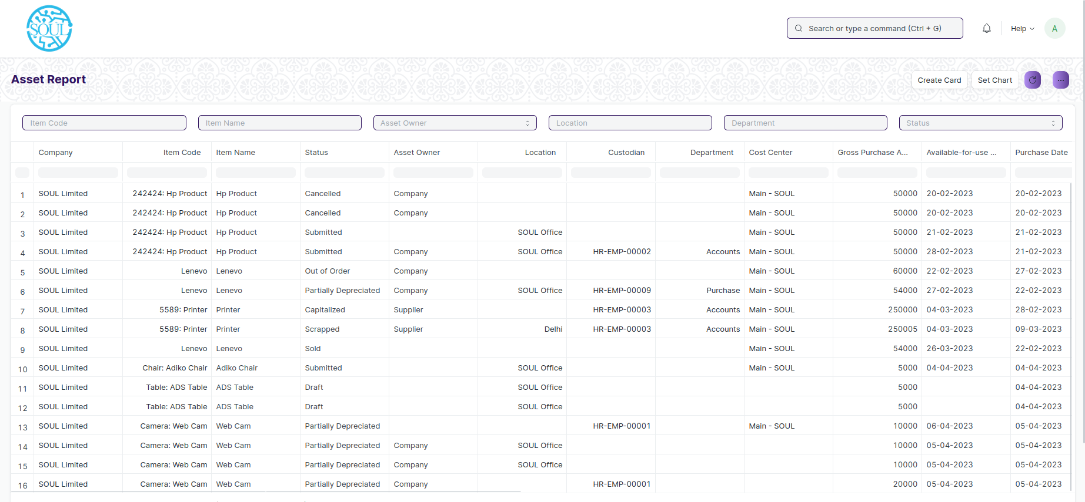

Figure : Asset Summary report

## Item Price Impalement report

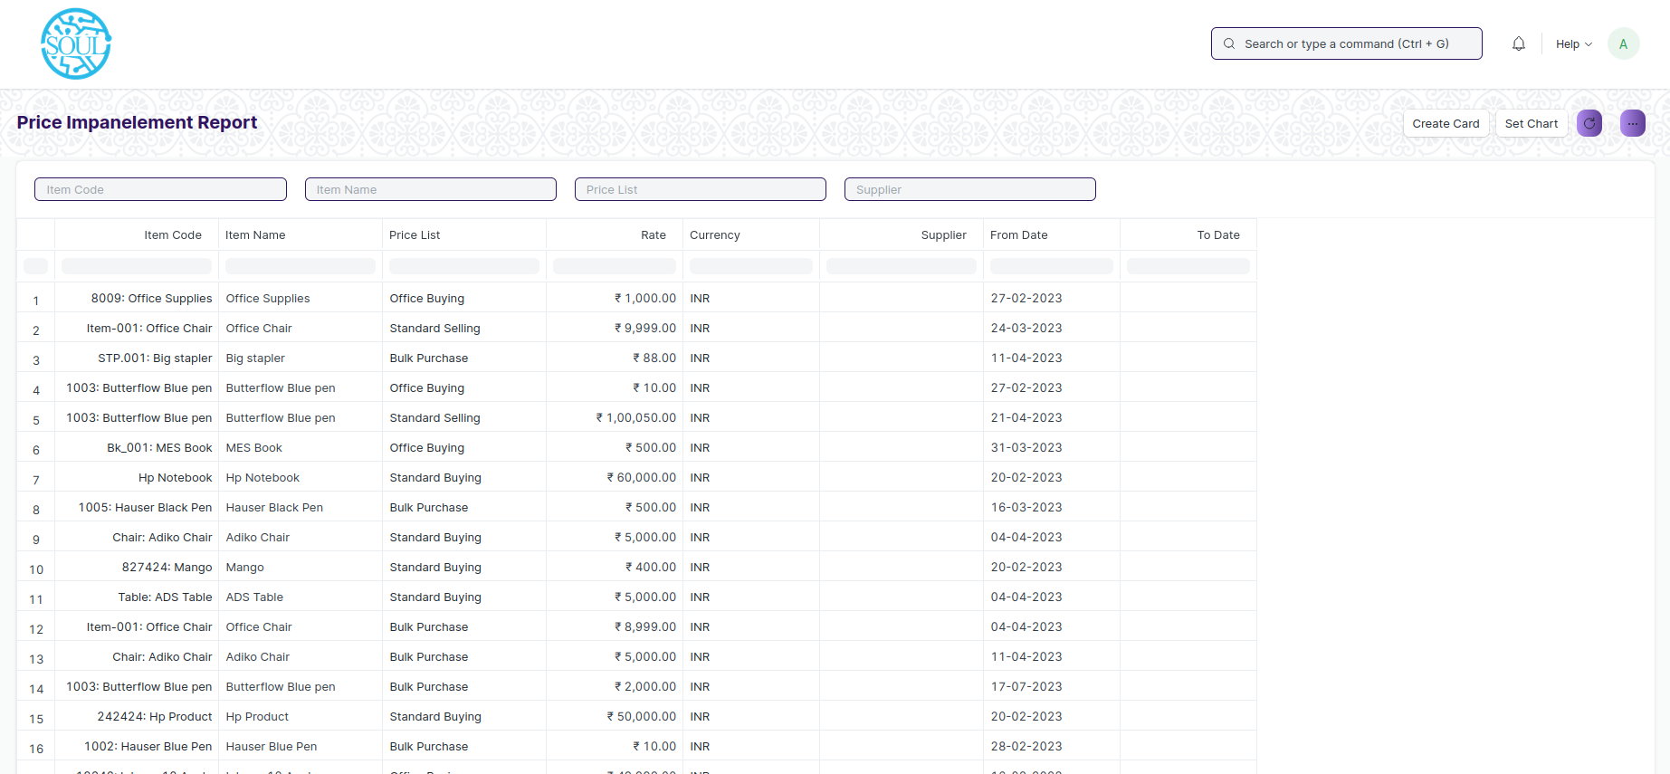

Figure : Item Price Impalement report

# Definitions and Acronyms

The following table explains the terms and abbreviations used in the document:

|  |  |
| --- | --- |
| **Abbreviation** | **Description** |
| HLD | High Level Design |
| LLD | Low Level Design |
| API | Application Programming interface |
| NA | Not Applicable |
| ERP | Enterprise Resource Planning |
| HRMS | Human Resource Management System |
| GDPR | General Data Protection Regulation |
| PCI DSS | Payment Card Industry Data Security Standard |

# Deployment Description

* Application Name: Campus Management Application At World Skill Center (WSC)
* Deployment Environment: Production
* Server Information: IP address:117.250.67.19, domain name:erp.worldskillcenter.org, hosting provider: OCAC
* Deployment Date: 13-06-2023
* Database Information: MariaDB 10.6.*, Installed on the same server as the Application